PISHPEK
No information has been found for this period yet
42.82913, 74.60733

Фотография пока не добавлена
ENGLISH
No information has been found for this period yet.

FRUNZE
Southern Gate
42.82913, 74.60733
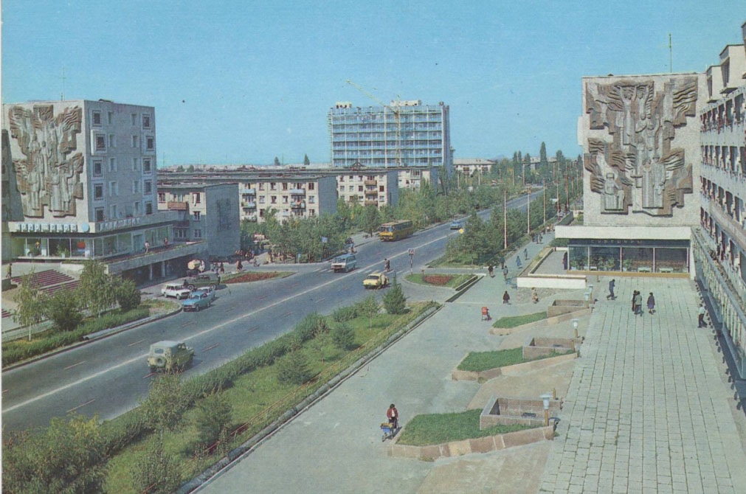
Южные ворота
ENGLISH Southern Gate
﻿ Southern Gate The architectural ensemble that completes the 8th and 10th microdistricts of the city. Architects R. Mukhamadiev, V. Kuznetsov, A. Soltobaev, Yu. Tagirov, 1978 The buildings seem to open the entrance to the city from the mountains. On the ground floors there are shops and cafes, on the roof there are artists' workshops. The facades of the buildings are decorated with mosaic panels “One Hundred Years of the City”, works by artists
Source: https://bimap.su/description/frunze/108_Ujnye_vorota.txt · BIMAP
Фотографии и материалы принадлежат их авторам; лицензия не указана

BISHKEK
No information has been found for this period yet
42.82913, 74.60733

Фотография пока не добавлена
ENGLISH
No information has been found for this period yet.

