PISHPEK
No information has been found for this period yet
42.87965, 74.60559

Фотография пока не добавлена
ENGLISH
No information has been found for this period yet.

FRUNZE
Government House
42.87965, 74.60559
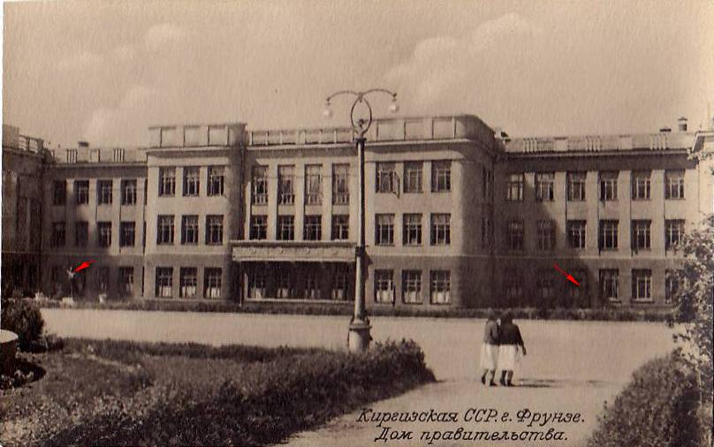
Дом правительства
ENGLISH Government House
﻿ Government House. Architect Yu.B. Dubov, 1936 Based on designs by Yu.B. Dubov more than forty buildings were built in the city. The most significant of them is the Government House. Strict architectural forms, rectangular window openings, gray plaster reflect the strength and inviolability of power. Spacious front lobbies, wide staircases, a bright meeting room decorated with mosaic portraits of the leaders of the revolution - everything corres
Source: https://bimap.su/description/frunze/106_Dom_Pravitelstva.txt · BIMAP
Фотографии и материалы принадлежат их авторам; лицензия не указана

BISHKEK
No information has been found for this period yet
42.87965, 74.60559

Фотография пока не добавлена
ENGLISH
No information has been found for this period yet.

