PISHPEK
No information has been found for this period yet
42.86826, 74.60950

Фотография пока не добавлена
ENGLISH
No information has been found for this period yet.

FRUNZE
House on Engels street
42.86826, 74.60950
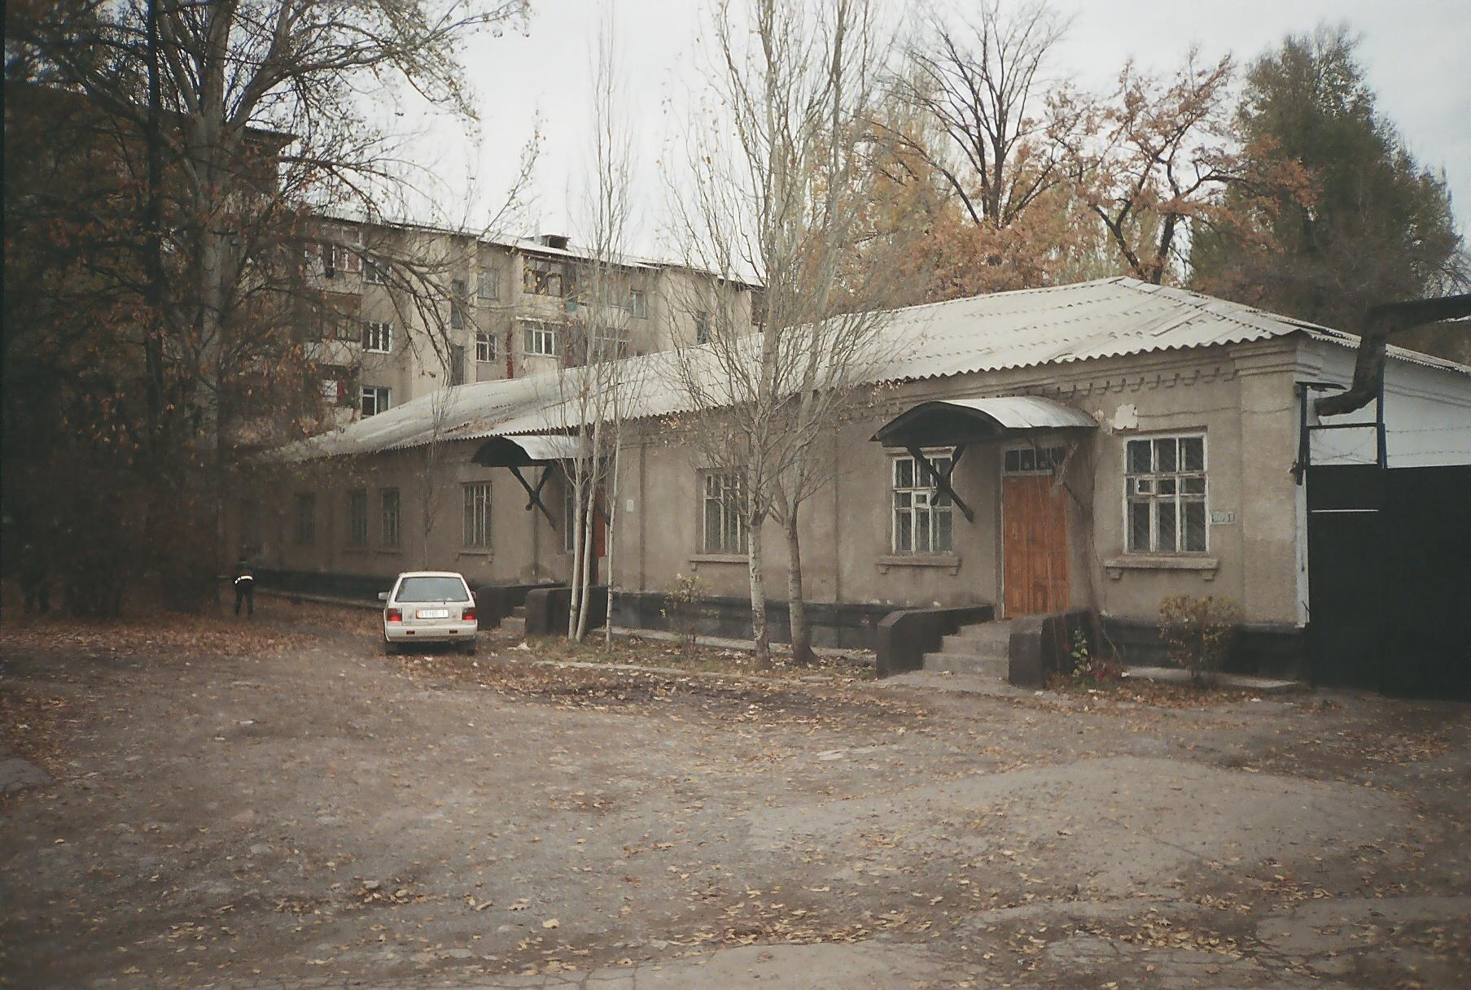
Дом по улице Энгельса
ENGLISH House on Engels street
﻿ House on the street. Engels, between Sovetskaya and Krasnooktyabrskaya The building was built in 1932 for the laboratory of the Zootechnical Institute (KIRNIIZh-Kyrgyz Research Institute of Animal Husbandry).
Source: https://bimap.su/description/frunze/104_KIRNIIJ.txt · BIMAP
Фотографии и материалы принадлежат их авторам; лицензия не указана

BISHKEK
No information has been found for this period yet
42.86826, 74.60950

Фотография пока не добавлена
ENGLISH
No information has been found for this period yet.

