PISHPEK
City government
42.87956, 74.60621
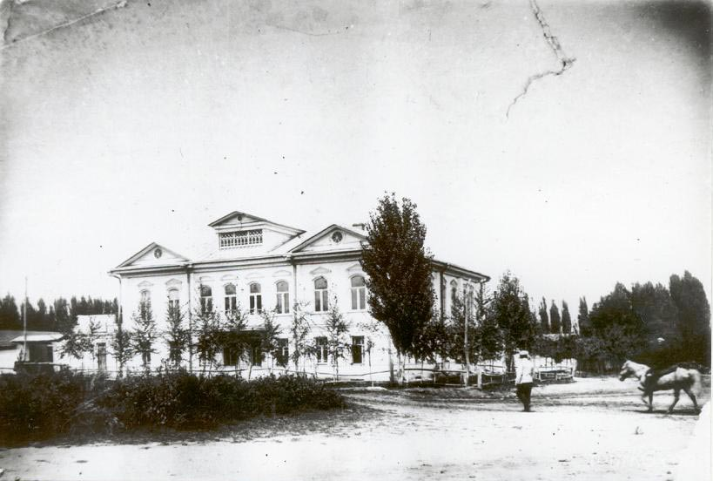
Городская управа
ENGLISH City government
﻿ City government on the northwestern corner of Uezdnaya and Boulevard streets in the house of Ilya Terentyev, built in 1907. Initially, no special administrative buildings were built in the city. The administration rented houses from wealthy townspeople, who not only maintained the premises, but also held high positions in them. The first city mayor was Nikanor Titovich Rybyanov, and from 1890 - Ivan Panteleevich Sapozhnikov. They said that he g
Source: https://bimap.su/description/pishpek/31_Uprava_goroda.txt · BIMAP
Фотографии и материалы принадлежат их авторам; лицензия не указана

FRUNZE
No information has been found for this period yet
42.87956, 74.60621

Фотография пока не добавлена
ENGLISH
No information has been found for this period yet.

BISHKEK
No information has been found for this period yet
42.87956, 74.60621

Фотография пока не добавлена
ENGLISH
No information has been found for this period yet.

