PISHPEK
No information has been found for this period yet
42.87628, 74.59975

Фотография пока не добавлена
ENGLISH
No information has been found for this period yet.

FRUNZE
House of Officers
42.87628, 74.59975
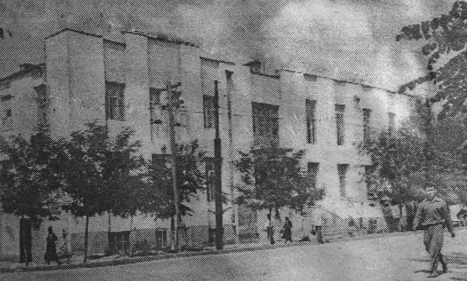
Дом офицеров
ENGLISH House of Officers
﻿ House of Officers, built in 1932. The House of the Red Army (later the House of Officers of the Soviet Army) was built in 1932 in the architectural style of constructivism, for which the characteristic forms were straight lines, large window openings, and the absence of decorative ornaments. On the second floor of the building there was a cinema, a library, and rooms for creativity. Later, bas-reliefs by Manuilova were installed at the front en
Source: https://bimap.su/description/frunze/101_DOSA.txt · BIMAP
Фотографии и материалы принадлежат их авторам; лицензия не указана

BISHKEK
No information has been found for this period yet
42.87628, 74.59975

Фотография пока не добавлена
ENGLISH
No information has been found for this period yet.

