PISHPEK
No information has been found for this period yet
42.86585, 74.58777

Фотография пока не добавлена
ENGLISH
No information has been found for this period yet.

FRUNZE
House of Children's Creativity
42.86585, 74.58777
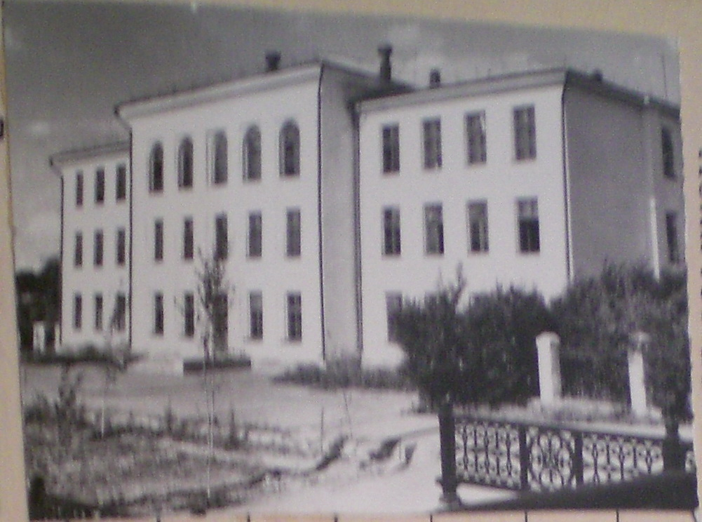
Дом детского творчества
ENGLISH House of Children's Creativity
﻿ House of Children's Creativity, 60th House of Children's Creativity (Station of Young Technicians). Created in 1961. There were 80 technical circles here (radio engineering and electronics, aircraft modeling, rocket and space, auto and ship modeling, etc.), in which more than 1,000 schoolchildren studied.
Source: https://bimap.su/description/frunze/98_Dom_tvorchestva.txt · BIMAP
Фотографии и материалы принадлежат их авторам; лицензия не указана

BISHKEK
No information has been found for this period yet
42.86585, 74.58777

Фотография пока не добавлена
ENGLISH
No information has been found for this period yet.

