PISHPEK
No information has been found for this period yet
42.87598, 74.59222

Фотография пока не добавлена
ENGLISH
No information has been found for this period yet.

FRUNZE
House of life
42.87598, 74.59222
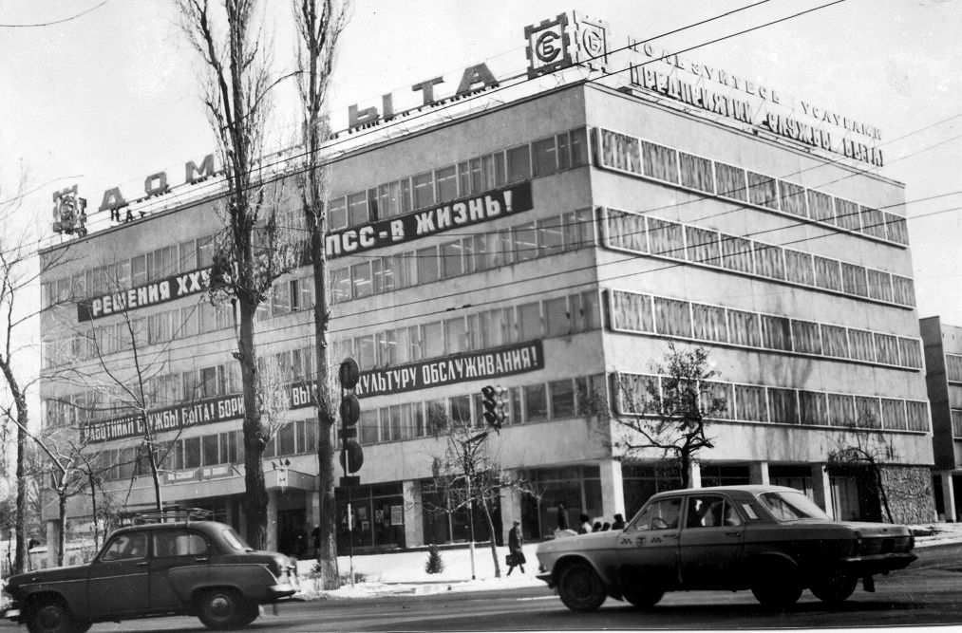
Дом быта · 1978 года
ENGLISH House of life
﻿ House of life. Photo from 1978 The building of the service center was built in 1975 (architects Y. Karikh, B. Moldobaev). Here you could repair watches, radios, glasses, shoes, jewelry, in total you could get 230 types of different services.
Source: https://bimap.su/description/frunze/97_Dom_byta.txt · BIMAP
Фотографии и материалы принадлежат их авторам; лицензия не указана

BISHKEK
No information has been found for this period yet
42.87598, 74.59222

Фотография пока не добавлена
ENGLISH
No information has been found for this period yet.

