PISHPEK
No information has been found for this period yet
42.87235, 74.60563

Фотография пока не добавлена
ENGLISH
No information has been found for this period yet.

FRUNZE
Residential building
42.87235, 74.60563
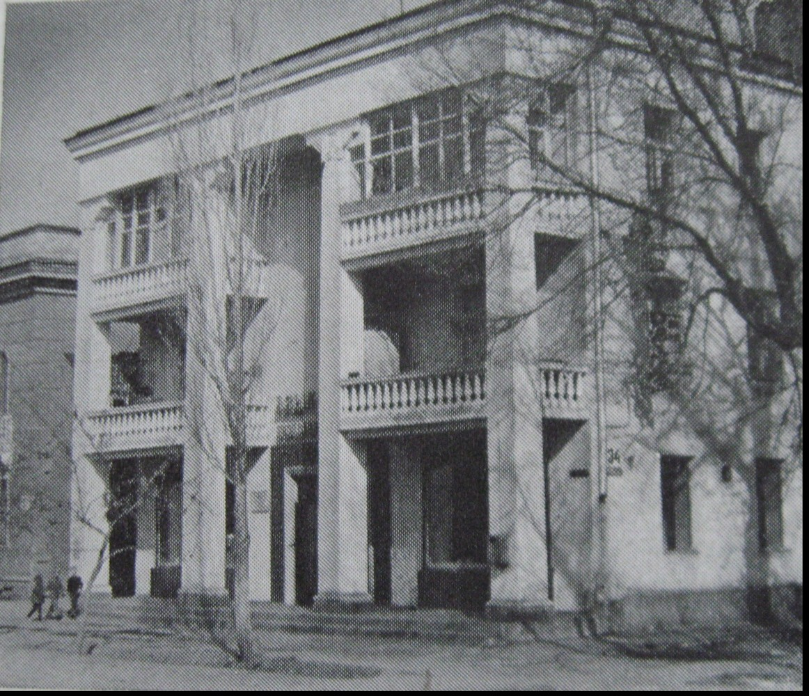
Жилой дом
ENGLISH Residential building
﻿ Residential building on the corner of Dzerzhinsky and Toktogul streets Residential building on the corner of Dzerzhinsky and Toktogul streets (architect V. Zmievsky, 30th). The architectural design of the facade used the Kyrgyz national ornament; loggias appeared that, taking into account the climatic conditions, had the appearance of light openwork gazebos.
Source: https://bimap.su/description/frunze/96_DzerToktogula.txt · BIMAP
Фотографии и материалы принадлежат их авторам; лицензия не указана

BISHKEK
No information has been found for this period yet
42.87235, 74.60563

Фотография пока не добавлена
ENGLISH
No information has been found for this period yet.

