PISHPEK
No information has been found for this period yet
42.87962, 74.60842

Фотография пока не добавлена
ENGLISH
No information has been found for this period yet.

FRUNZE
State Circus
42.87962, 74.60842
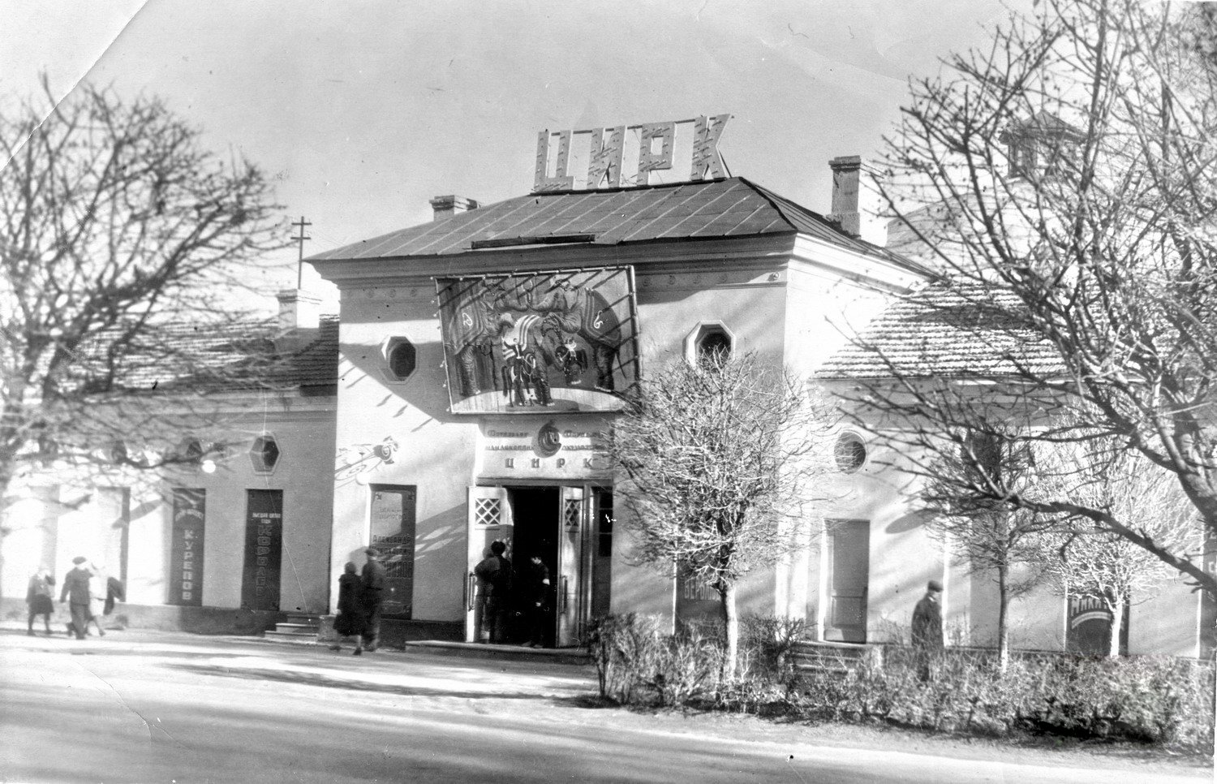
Госцирк
ENGLISH State Circus
﻿ State Circus. The building was built in the early 40s by the State Circus. The building was built in the early 40s. The old wooden circus, cut from Tien Shan spruce, could stand forever. It hosted tours of the famous trainers the Durovs, the tiger tamer Bugrimova, the clowns Berman, Karandash, Oleg Popov, the man without arms under the pseudonym Sandro da Dej and many other magnificent artists who performed in this cozy building of the old circ
Source: https://bimap.su/description/frunze/89_Goszirk50.txt · BIMAP
Фотографии и материалы принадлежат их авторам; лицензия не указана

BISHKEK
No information has been found for this period yet
42.87962, 74.60842

Фотография пока не добавлена
ENGLISH
No information has been found for this period yet.

