PISHPEK
No information has been found for this period yet
42.87967, 74.59769

Фотография пока не добавлена
ENGLISH
No information has been found for this period yet.

FRUNZE
Spartak Stadium
42.87967, 74.59769
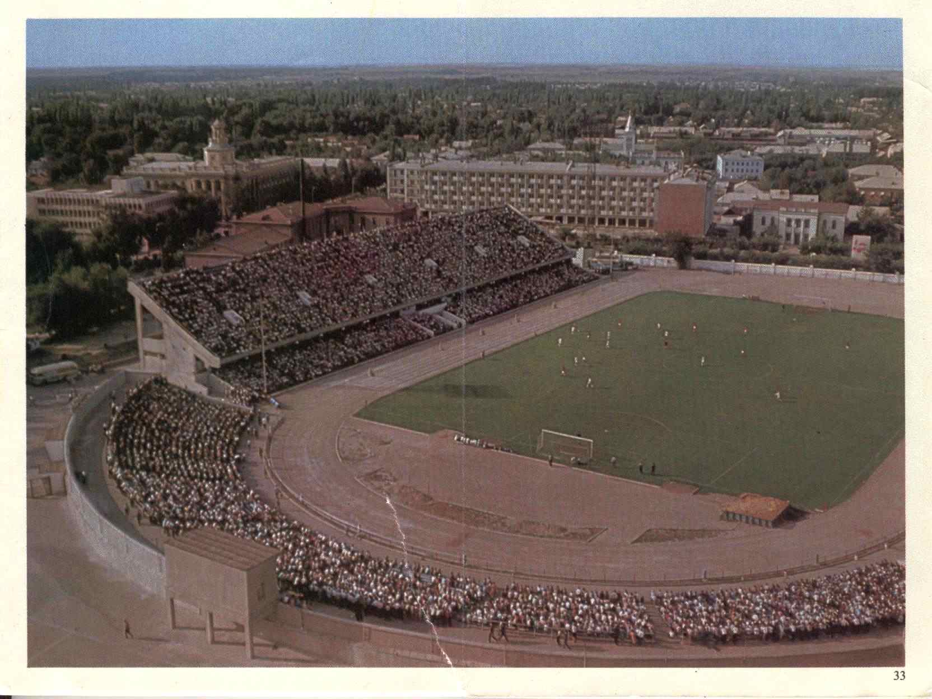
Стадион «Спартак»
ENGLISH Spartak Stadium
﻿ Spartak Stadium, 60s Spartak Stadium was built in 1941 and reconstructed in 1963. The stadium hosts football matches, various competitions and celebrations.
Source: https://bimap.su/description/frunze/85_Stadion60.txt · BIMAP
Фотографии и материалы принадлежат их авторам; лицензия не указана

BISHKEK
No information has been found for this period yet
42.87967, 74.59769

Фотография пока не добавлена
ENGLISH
No information has been found for this period yet.

