PISHPEK
Siege of the fortress
42.88581, 74.61746
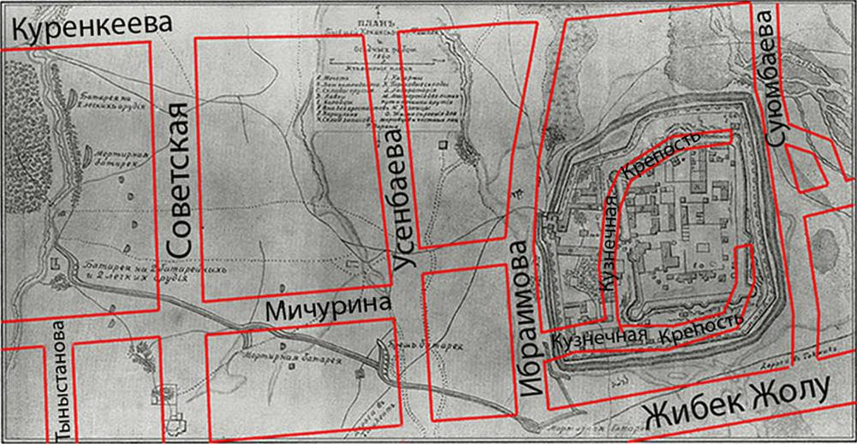
Осада крепости
ENGLISH Siege of the fortress
﻿ Siege of the Pishpek fortress on the city plan. On August 30, 1860, the royal detachment arrived at Pishpek and its siege began on the western side of the Ala-Archa River. “The Guide to Turkestan for 1912” wrote that “during this short-term siege, a remarkable shot was fired from the guns operating from the breach battery under the command of Staff Captain Obukh. The enemy guns located on one of the Pishpek towers were shot down, and one cannon
Source: https://bimap.su/description/pishpek/29_Osada.txt · BIMAP
Фотографии и материалы принадлежат их авторам; лицензия не указана

FRUNZE
No information has been found for this period yet
42.88581, 74.61746

Фотография пока не добавлена
ENGLISH
No information has been found for this period yet.

BISHKEK
No information has been found for this period yet
42.88581, 74.61746

Фотография пока не добавлена
ENGLISH
No information has been found for this period yet.

