PISHPEK
No information has been found for this period yet
42.87954, 74.61115

Фотография пока не добавлена
ENGLISH
No information has been found for this period yet.

FRUNZE
City Committee
42.87954, 74.61115
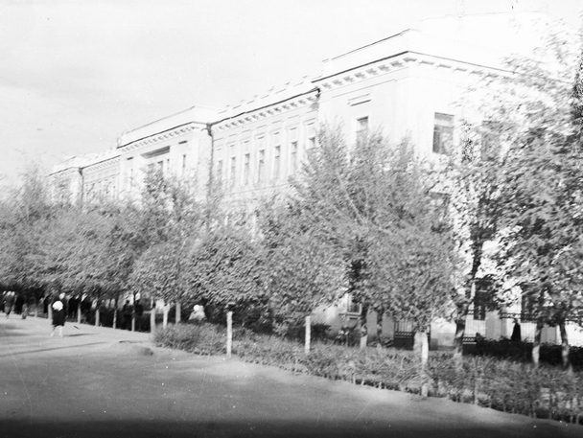
Горком
ENGLISH City Committee
﻿ City Committee. The building was built in 1940. The building was originally built as the Administration of BChKstroy (architects F.P. Steblin, S.Kh. Sahakyan). Later, the City Party Committee and the editorial offices of republican newspapers and magazines were located here.
Source: https://bimap.su/description/frunze/82_Gorkom.txt · BIMAP
Фотографии и материалы принадлежат их авторам; лицензия не указана

BISHKEK
No information has been found for this period yet
42.87954, 74.61115

Фотография пока не добавлена
ENGLISH
No information has been found for this period yet.

