PISHPEK
No information has been found for this period yet
42.80450, 74.58112

Фотография пока не добавлена
ENGLISH
No information has been found for this period yet.

FRUNZE
VDNKh, Main Pavilion
42.80450, 74.58112
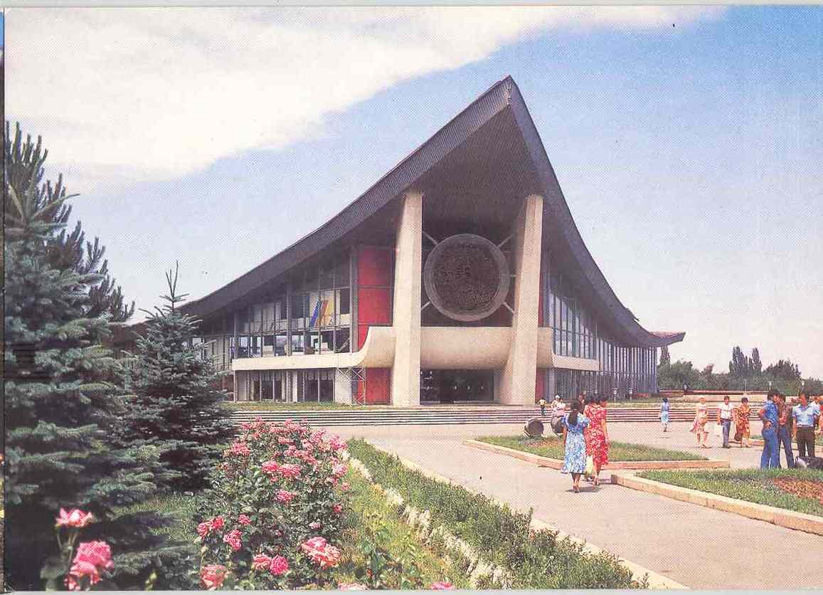
ВДНХ, Главный павильон · Шерстенникова
ENGLISH VDNKh, Main Pavilion
﻿ VDNH, Main Pavilion. Photo by Sherstennikov, 1984 VDNH of the Kirghiz SSR dates back to 1947 as the Kyrgyz Republican Agricultural Exhibition. The total area of ​​the Exhibition is 110 hectares, of which 32 hectares are the main area, 21 hectares are occupied by grapes and fruit trees, 16 hectares are occupied by various plants. Almost all types of flora in Kyrgyzstan are concentrated here, more than 15 varieties of fruit trees, 20 types of flo
Source: https://bimap.su/description/frunze/80_VDNX1.txt · BIMAP
Фотографии и материалы принадлежат их авторам; лицензия не указана

BISHKEK
No information has been found for this period yet
42.80450, 74.58112

Фотография пока не добавлена
ENGLISH
No information has been found for this period yet.

