PISHPEK
No information has been found for this period yet
42.83887, 74.58340

Фотография пока не добавлена
ENGLISH
No information has been found for this period yet.

FRUNZE
Sculpture by Valery Chkalov
42.83887, 74.58340
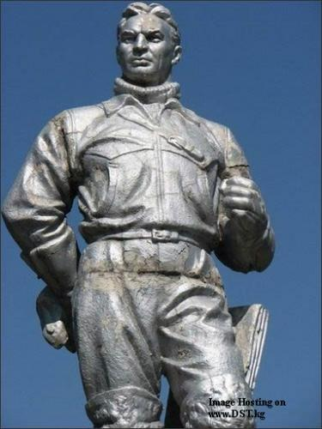
Скульптура Валерия Чкалова
ENGLISH Sculpture by Valery Chkalov
﻿ Sculpture by Valery Chkalov Sculpture by Valery Chkalov at Frunze Airport.
Source: https://bimap.su/description/frunze/74_Chkalov.txt · BIMAP
Фотографии и материалы принадлежат их авторам; лицензия не указана

BISHKEK
No information has been found for this period yet
42.83887, 74.58340

Фотография пока не добавлена
ENGLISH
No information has been found for this period yet.

