PISHPEK
No information has been found for this period yet
42.87687, 74.58788

Фотография пока не добавлена
ENGLISH
No information has been found for this period yet.

FRUNZE
Philharmonic
42.87687, 74.58788
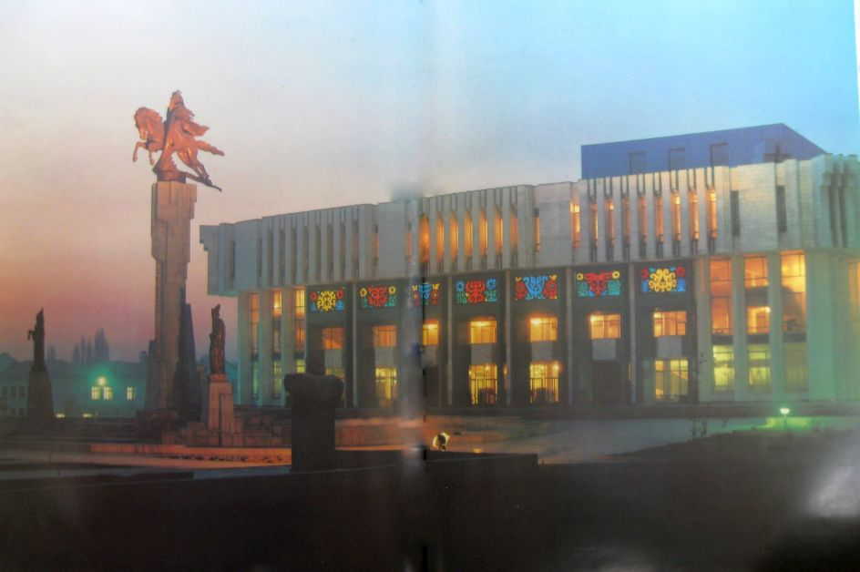
Филармония
ENGLISH Philharmonic
﻿ Philharmonic. Photo from the album Kyrgyzstan, 1985 Philharmonic. The building was built in 1980. Architect A. Pechenochkin. The large hall seats 1,200, the small hall seats 300. The sculptural composition “Manas” was erected in front of the building.
Source: https://bimap.su/description/frunze/72_Filarmonia.txt · BIMAP
Фотографии и материалы принадлежат их авторам; лицензия не указана

BISHKEK
No information has been found for this period yet
42.87687, 74.58788

Фотография пока не добавлена
ENGLISH
No information has been found for this period yet.

