PISHPEK
No information has been found for this period yet
42.87659, 74.58656

Фотография пока не добавлена
ENGLISH
No information has been found for this period yet.

FRUNZE
Sovetskaya Square
42.87659, 74.58656
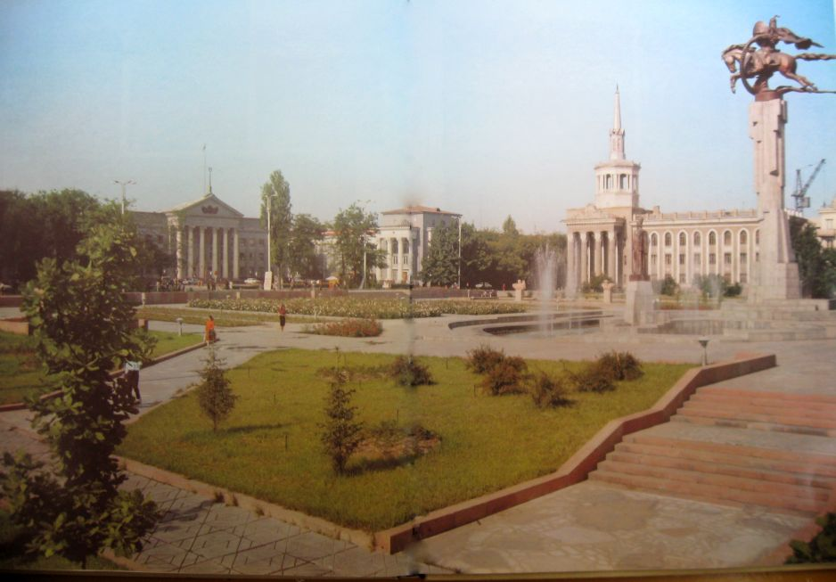
Советская площадь
ENGLISH Sovetskaya Square
﻿ Sovetskaya Square. Photo from the album Kyrgyzstan, 1985 Soviet Square. The architectural ensemble of the square consists of the buildings of the City Executive Committee, the Ministry of Agriculture, the Polytechnic College and the Philharmonic, in front of which the sculptural composition “Manas” was erected.
Source: https://bimap.su/description/frunze/70_Sovplotchat.txt · BIMAP
Фотографии и материалы принадлежат их авторам; лицензия не указана

BISHKEK
City square
42.87659, 74.58656
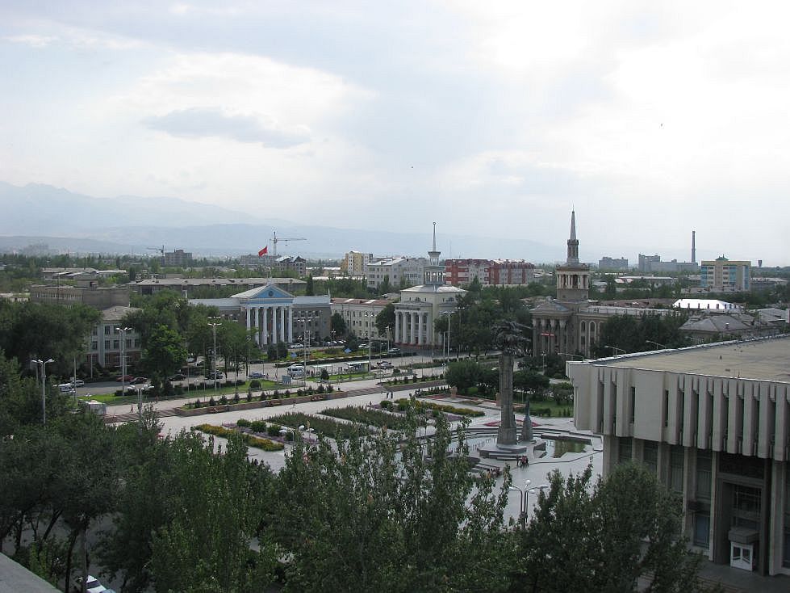
Городская площадь · Евгения Коровина
ENGLISH City square
City square. Photo by Evgeny Korovin.
Source: https://bimap.su/description/bishkek/37_IMG_0363.txt · BIMAP
Фотографии и материалы принадлежат их авторам; лицензия не указана

