PISHPEK
No information has been found for this period yet
42.87591, 74.60688

Фотография пока не добавлена
ENGLISH
No information has been found for this period yet.

FRUNZE
The intersection of Dzerzhinsky Boulevard and Stalin Street
42.87591, 74.60688
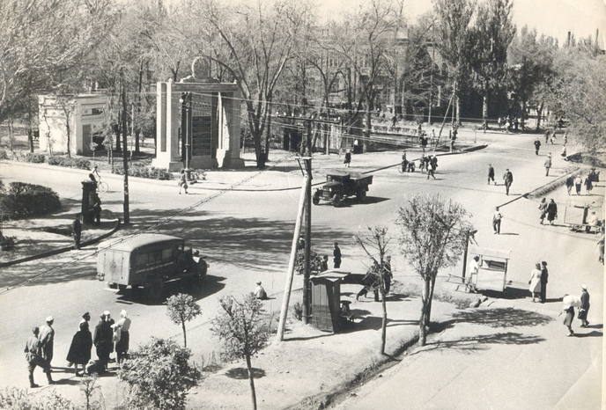
Пересечение бульвара Дзержинского и улицы Сталина
ENGLISH The intersection of Dzerzhinsky Boulevard and Stalin Street
﻿ Dzerzhinskaya x Stalina Dzerzhinskaya x Stalina (Erkindik x Chui). The photo was taken from the 50s from the Ala-Too cinema. In the background is the “Roll of Honor” and the telegraph building.
Source: https://bimap.su/description/frunze/65_DzerStalina.txt · BIMAP
Фотографии и материалы принадлежат их авторам; лицензия не указана

BISHKEK
No information has been found for this period yet
42.87591, 74.60688

Фотография пока не добавлена
ENGLISH
No information has been found for this period yet.

