PISHPEK
Plan of the Kokand fortresses Pishpek and Tokmak
42.88686, 74.62070
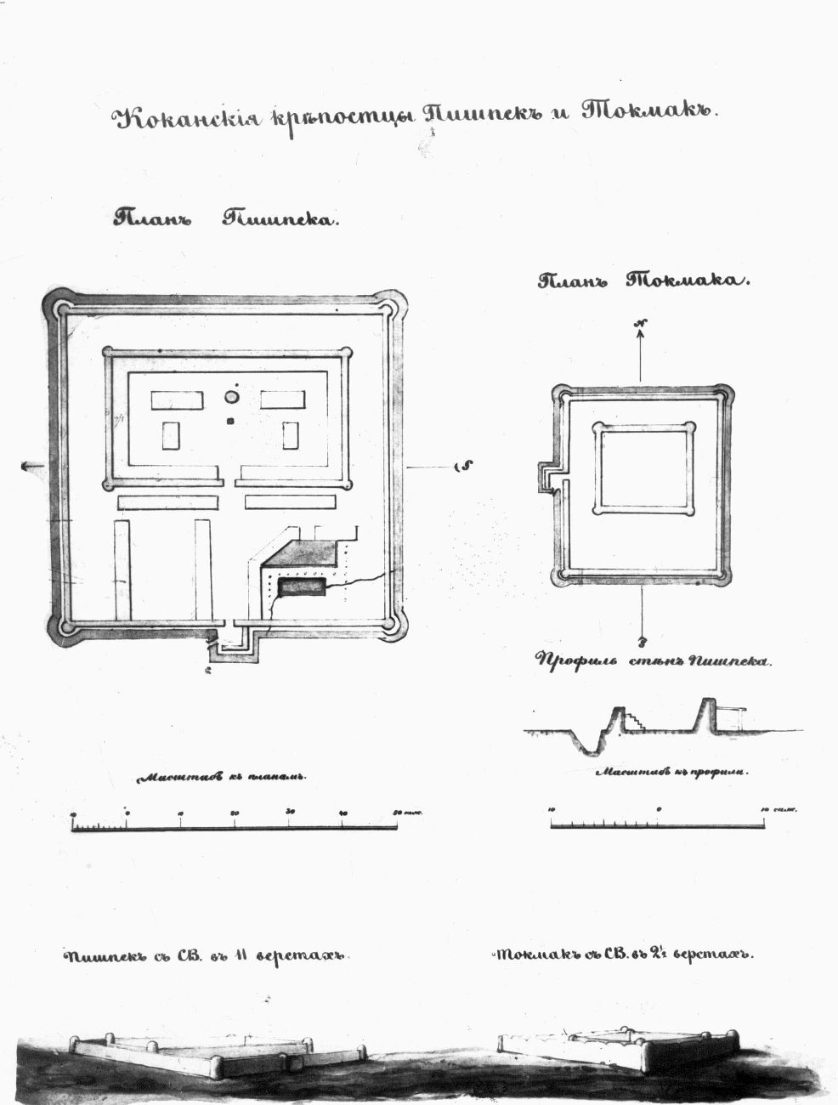
План кокандских крепостей Пишпек и Токмак
ENGLISH Plan of the Kokand fortresses Pishpek and Tokmak
﻿ Plan of the Kokand fortresses Pishpek and Tokmak Pishpek was the largest Kokand fortress in the Chui Valley. In plan, the fortress was close to a quadrangle, the length of the sides was more than 200 meters, the height of the walls reached five meters with a width of up to four meters. There was a ditch filled with water along the perimeter. Corner towers and jagged projections along the top of the walls enhanced the defensive power of the fort
Source: https://bimap.su/description/pishpek/27_Plan.txt · BIMAP
Фотографии и материалы принадлежат их авторам; лицензия не указана

FRUNZE
No information has been found for this period yet
42.88686, 74.62070

Фотография пока не добавлена
ENGLISH
No information has been found for this period yet.

BISHKEK
No information has been found for this period yet
42.88686, 74.62070

Фотография пока не добавлена
ENGLISH
No information has been found for this period yet.

