PISHPEK
No information has been found for this period yet
42.87909, 74.60555

Фотография пока не добавлена
ENGLISH
No information has been found for this period yet.

FRUNZE
Central Square
42.87909, 74.60555
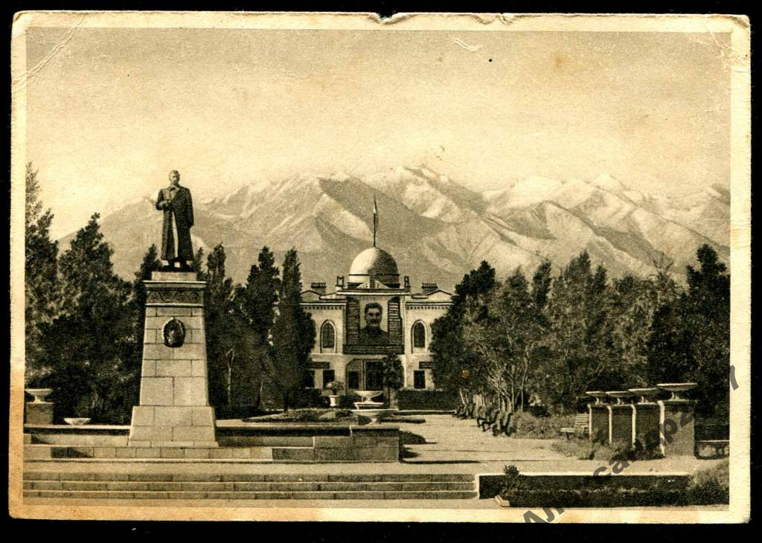
Центральный сквер
ENGLISH Central Square
﻿ Central Square The square was laid out in 1933 according to the European system by gardener Joseph Racek. The Central Election Commission building is in the background. The sculpture of I.V. Stalin was installed in 1938.
Source: https://bimap.su/description/frunze/64_Skver.txt · BIMAP
Фотографии и материалы принадлежат их авторам; лицензия не указана

BISHKEK
No information has been found for this period yet
42.87909, 74.60555

Фотография пока не добавлена
ENGLISH
No information has been found for this period yet.

