PISHPEK
Kokand fortress Pishpek
42.88670, 74.61910
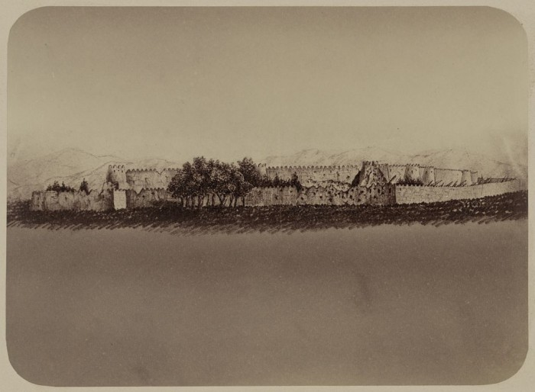
Кокандская крепость Пишпек
ENGLISH Kokand fortress Pishpek
﻿ Kokand fortress Pishpek. Founded in 1825. There is a legend that in the middle of the 18th century, a Kyrgyz fortification was built on the ruins of an ancient settlement, in which in 1766 the Kyrgyz withstood the siege of the Kazakh Sultan Ablai. According to legend, Bishkek, one of the descendants of Joozhalysh from the Solto tribe, was buried here, and therefore the fortification founded in 1825 by the Kokand people received the name of the
Source: https://bimap.su/description/pishpek/26_Krepost.txt · BIMAP
Фотографии и материалы принадлежат их авторам; лицензия не указана

FRUNZE
Fortress
42.88670, 74.61910
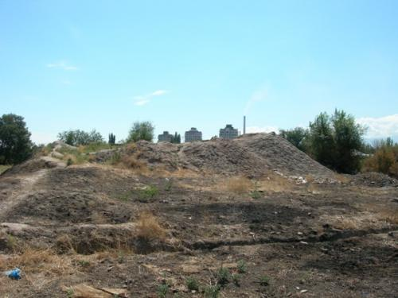
Крепость
ENGLISH Fortress
﻿ Fortress This is all that remains of the Forge settlement and the Pishpek fortress.
Source: https://bimap.su/description/frunze/440_Krepost.txt · BIMAP
Фотографии и материалы принадлежат их авторам; лицензия не указана

BISHKEK
No information has been found for this period yet
42.88670, 74.61910

Фотография пока не добавлена
ENGLISH
No information has been found for this period yet.

