PISHPEK
No information has been found for this period yet
42.87817, 74.59561

Фотография пока не добавлена
ENGLISH
No information has been found for this period yet.

FRUNZE
Sports Palace
42.87817, 74.59561
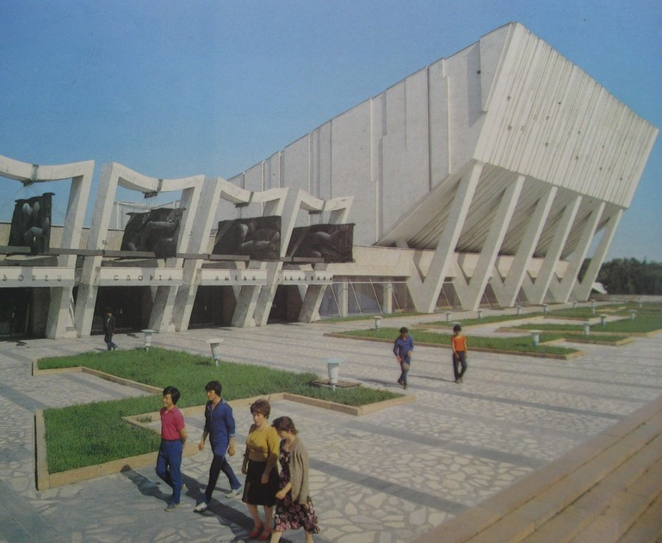
Дворец спорта
ENGLISH Sports Palace
﻿ Sports Palace. Photo from the album Kyrgyzstan, 1985. Sports Palace named after. V.I. Lenin (architects N. Kostin and V. Marukov, 1974) Sports competitions, pop performances, and special events were held here.
Source: https://bimap.su/description/frunze/54_Dvorets_sporta.txt · BIMAP
Фотографии и материалы принадлежат их авторам; лицензия не указана

BISHKEK
No information has been found for this period yet
42.87817, 74.59561

Фотография пока не добавлена
ENGLISH
No information has been found for this period yet.

