PISHPEK
No information has been found for this period yet
42.87969, 74.60398

Фотография пока не добавлена
ENGLISH
No information has been found for this period yet.

FRUNZE
House with columns
42.87969, 74.60398
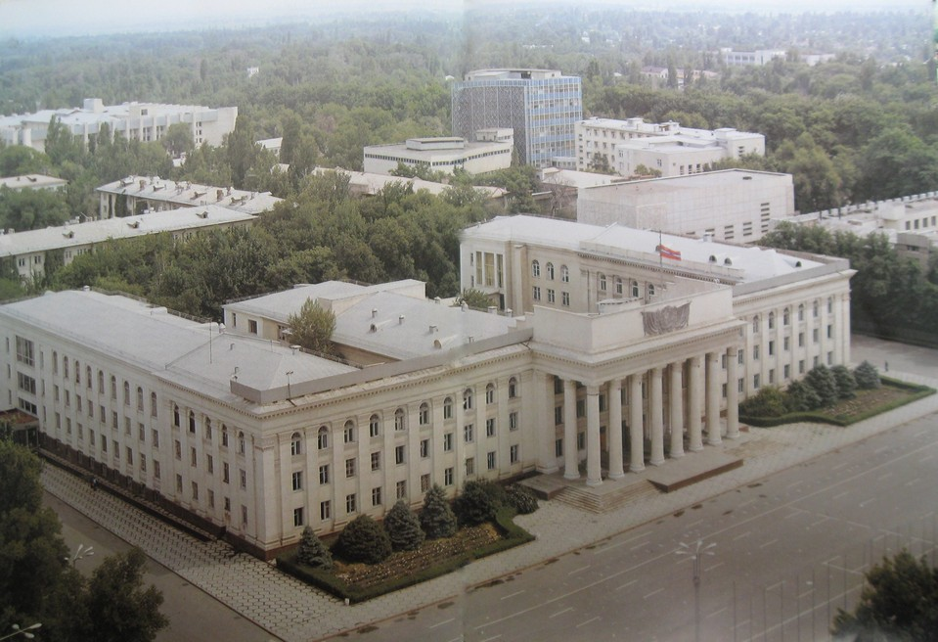
Дом с колоннами
ENGLISH House with columns
﻿ House with columns. Photo from the album Kyrgyzstan, 1985. In 1956, on the Central Square next to the Government House, the construction of the monumental building of the Republican Party School was completed (architects A.M. Albansky, R.I. Semerdzhiev, G. Nazaryan). In 1966, after a significant reconstruction and expansion of the building, it housed the Central Committee of the Communist Party of Kyrgyzstan and the Council of Ministers of the
Source: https://bimap.su/description/frunze/53_Dom_s_kollonami.txt · BIMAP
Фотографии и материалы принадлежат их авторам; лицензия не указана

BISHKEK
No information has been found for this period yet
42.87969, 74.60398

Фотография пока не добавлена
ENGLISH
No information has been found for this period yet.

