PISHPEK
No information has been found for this period yet
42.87110, 74.56730

Фотография пока не добавлена
ENGLISH
No information has been found for this period yet.

FRUNZE
Flour Mill
42.87110, 74.56730
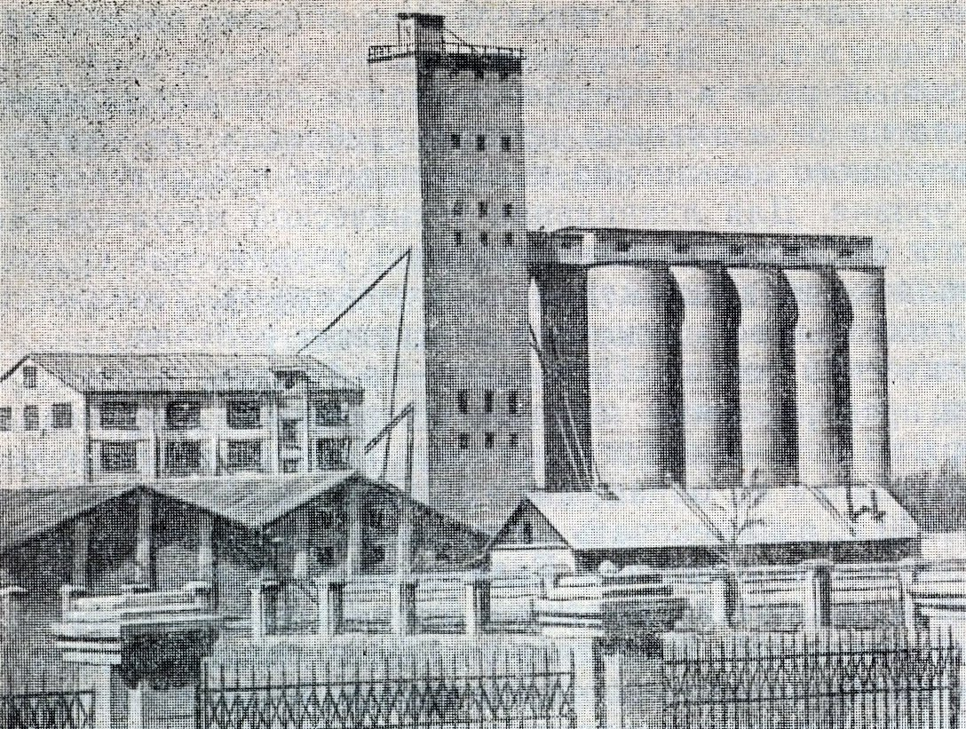
Мелькомбинат
ENGLISH Flour Mill
﻿ Flour Mill Created in 1929 as the Frunze mill. In 1935, a reinforced concrete elevator was put into operation, and in 1965, the 2nd elevator was put into operation. Produces flour, cereals, animal feed. The number of workers in 1982 was 640 people.
Source: https://bimap.su/description/frunze/52_Melkombinat.txt · BIMAP
Фотографии и материалы принадлежат их авторам; лицензия не указана

BISHKEK
No information has been found for this period yet
42.87110, 74.56730

Фотография пока не добавлена
ENGLISH
No information has been found for this period yet.

