PISHPEK
No information has been found for this period yet
42.89433, 74.63579

Фотография пока не добавлена
ENGLISH
No information has been found for this period yet.

FRUNZE
Construction of the Big Chui Canal
42.89433, 74.63579
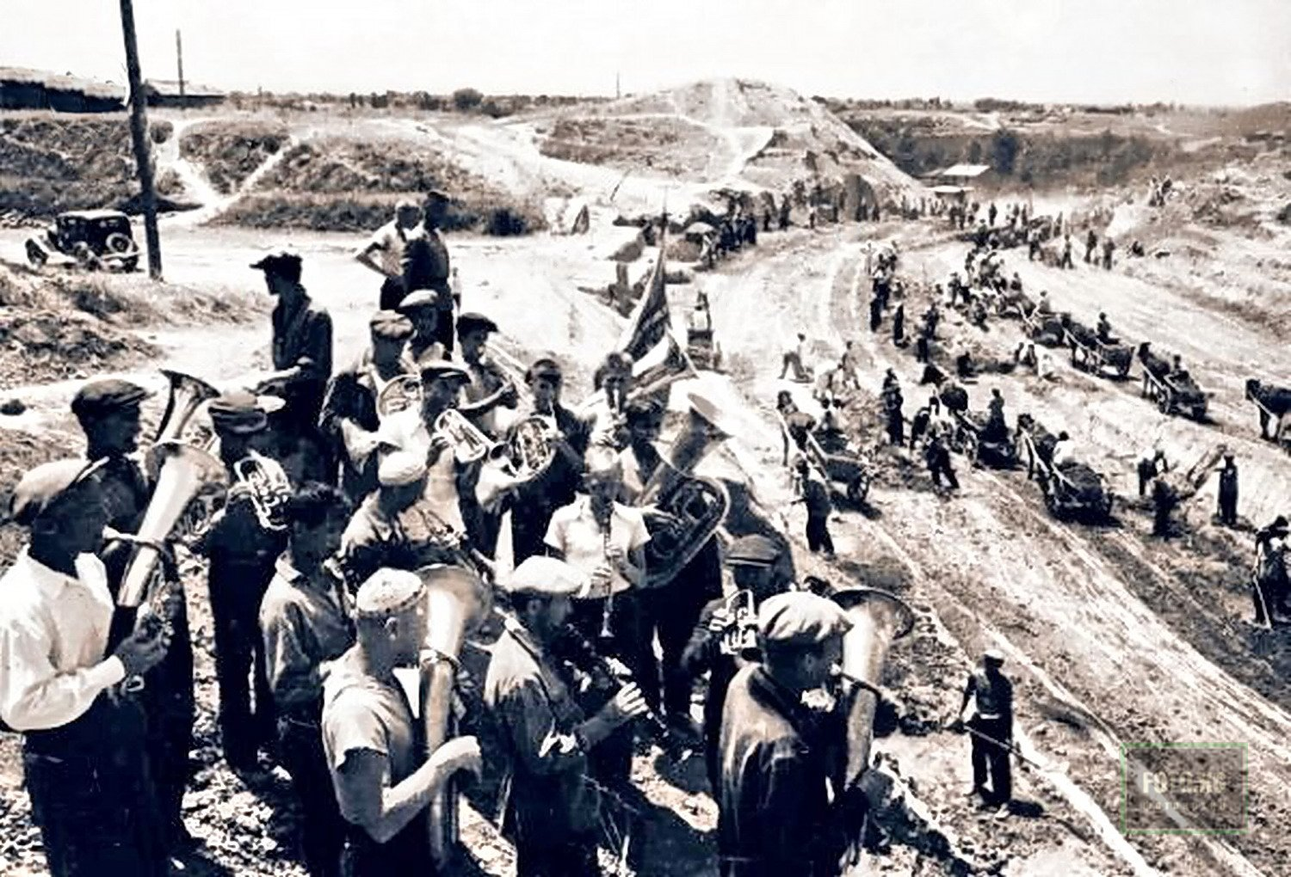
Строительство Большого Чуйского канала
ENGLISH Construction of the Big Chui Canal
﻿ Construction of the Big Chui Canal The Big Chui Canal crosses the entire Chui Valley from east to west. Its length is 145 km. Construction began in 1940. It was carried out using the method of popular construction - the mobilization of more than 40 thousand residents of the city of Frunze and the rural population. Construction was completed in 1943.
Source: https://bimap.su/description/frunze/50_BCHK.txt · BIMAP
Фотографии и материалы принадлежат их авторам; лицензия не указана

BISHKEK
No information has been found for this period yet
42.89433, 74.63579

Фотография пока не добавлена
ENGLISH
No information has been found for this period yet.

