PISHPEK
No information has been found for this period yet
42.87966, 74.61548

Фотография пока не добавлена
ENGLISH
No information has been found for this period yet.

FRUNZE
Collective farm market
42.87966, 74.61548
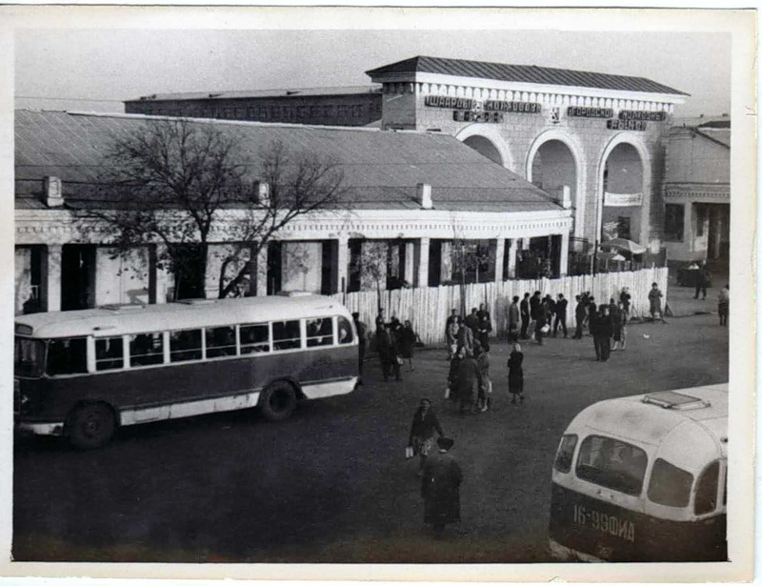
Колхозный рынок
ENGLISH Collective farm market
﻿ Collective farm market. View from the side of Shopokov Street The collective farm market was located within the streets of Frunze, Pravda (Ibraimov), K. Marx (Ryskulov), Shopokov where Victory Square is located today.
Source: https://bimap.su/description/frunze/46_Kolhozhyi_Rynok.txt · BIMAP
Фотографии и материалы принадлежат их авторам; лицензия не указана

BISHKEK
No information has been found for this period yet
42.87966, 74.61548

Фотография пока не добавлена
ENGLISH
No information has been found for this period yet.

