PISHPEK
Seraphim Church
42.87695, 74.57971
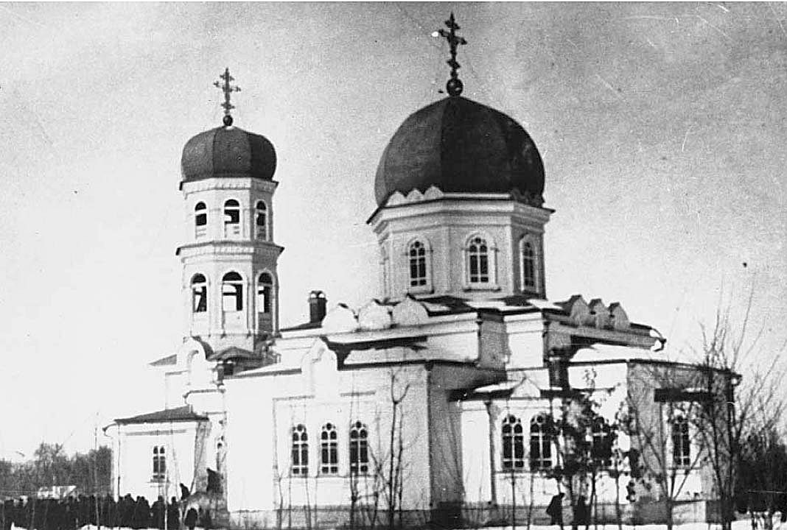
Серафимовская церковь
ENGLISH Seraphim Church
﻿ Seraphim Church. Built in 1906, the Temple of Seraphim of Sarov was built on the western outskirts of Pishpek for two years. The church was the tallest and most beautiful building in the city. Its dome and bell tower, crowned with crosses, were visible from afar. In plan, the building had the shape of a cross, along the longitudinal axis of which rose the tents of a wide dome and a bell tower with seven bells. The two-tier bell tower, consistin
Source: https://bimap.su/description/pishpek/25_Church.txt · BIMAP
Фотографии и материалы принадлежат их авторам; лицензия не указана

FRUNZE
No information has been found for this period yet
42.87695, 74.57971

Фотография пока не добавлена
ENGLISH
No information has been found for this period yet.

BISHKEK
No information has been found for this period yet
42.87695, 74.57971

Фотография пока не добавлена
ENGLISH
No information has been found for this period yet.

