PISHPEK
No information has been found for this period yet
42.87537, 74.59093

Фотография пока не добавлена
ENGLISH
No information has been found for this period yet.

FRUNZE
House on Kievskaya Street
42.87537, 74.59093
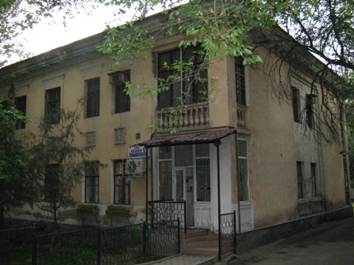
Дом на улице Киевской
ENGLISH House on Kievskaya Street
﻿ House on Kievskaya A two-story residential building built in the 50s.
Source: https://bimap.su/description/frunze/41_Dom_na_Kievskoi.txt · BIMAP
Фотографии и материалы принадлежат их авторам; лицензия не указана

BISHKEK
No information has been found for this period yet
42.87537, 74.59093

Фотография пока не добавлена
ENGLISH
No information has been found for this period yet.

