PISHPEK
No information has been found for this period yet
42.86764, 74.59535

Фотография пока не добавлена
ENGLISH
No information has been found for this period yet.

FRUNZE
Institute of Motherhood and Childhood
42.86764, 74.59535
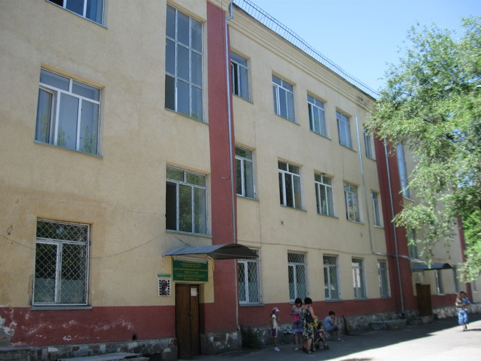
Институт материнства и детства · Владимира Петрова
ENGLISH Institute of Motherhood and Childhood
﻿ Institute of Motherhood and Childhood. Photo by Petrov The building of the Institute of Motherhood and Childhood was built in 1940.
Source: https://bimap.su/description/frunze/39_Institut_Materi.txt · BIMAP
Фотографии и материалы принадлежат их авторам; лицензия не указана

BISHKEK
No information has been found for this period yet
42.86764, 74.59535

Фотография пока не добавлена
ENGLISH
No information has been found for this period yet.

