PISHPEK
No information has been found for this period yet
42.86926, 74.60420

Фотография пока не добавлена
ENGLISH
No information has been found for this period yet.

FRUNZE
Pervomaisky district
42.86926, 74.60420
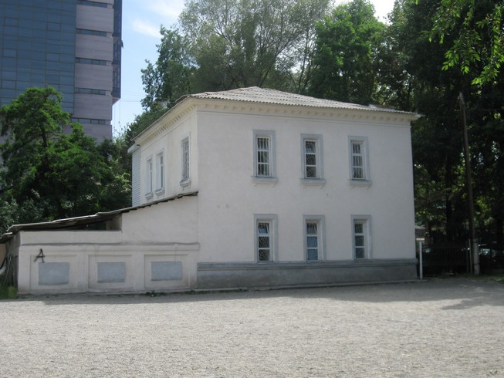
Первомайское районо · Владимира Петрова
ENGLISH Pervomaisky district
﻿ Pervomaisky district. Photo by Petrov Administrative building built in the 50s.
Source: https://bimap.su/description/frunze/38_Raiono.txt · BIMAP
Фотографии и материалы принадлежат их авторам; лицензия не указана

BISHKEK
No information has been found for this period yet
42.86926, 74.60420

Фотография пока не добавлена
ENGLISH
No information has been found for this period yet.

