PISHPEK
No information has been found for this period yet
42.86227, 74.59423

Фотография пока не добавлена
ENGLISH
No information has been found for this period yet.

FRUNZE
Infectious Diseases Hospital
42.86227, 74.59423
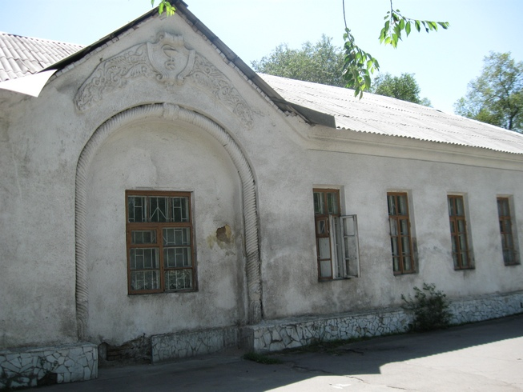
Инфекционная больница · Владимира Петрова
ENGLISH Infectious Diseases Hospital
﻿ Infectious Diseases Hospital. Photo by Petrov Opened in 1942 on the basis of the infectious diseases department of the Republican Clinical Hospital.
Source: https://bimap.su/description/frunze/34_Bolnitsa.txt · BIMAP
Фотографии и материалы принадлежат их авторам; лицензия не указана

BISHKEK
No information has been found for this period yet
42.86227, 74.59423

Фотография пока не добавлена
ENGLISH
No information has been found for this period yet.

