PISHPEK
Belfry
42.87819, 74.60674
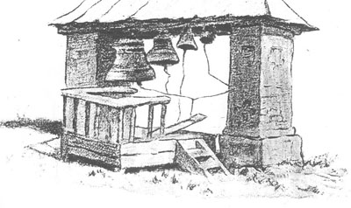
Звонница
ENGLISH Belfry
﻿ St. Nicholas Church, belfry. Built in 1886. In 1867, with the help of believers, a temporary church of St. Nicholas was built from adobe brick, which served the parishioners for almost twenty years. In 1886, thanks to the funds raised and donations from the merchant N.I. Ivanov, a stone cathedral was erected in the same place in the name of St. Nicholas the Wonderworker. The belfry was destroyed in 1935.
Source: https://bimap.su/description/pishpek/24_Church.txt · BIMAP
Фотографии и материалы принадлежат их авторам; лицензия не указана

FRUNZE
No information has been found for this period yet
42.87819, 74.60674

Фотография пока не добавлена
ENGLISH
No information has been found for this period yet.

BISHKEK
No information has been found for this period yet
42.87819, 74.60674

Фотография пока не добавлена
ENGLISH
No information has been found for this period yet.

