PISHPEK
No information has been found for this period yet
42.86548, 74.58922

Фотография пока не добавлена
ENGLISH
No information has been found for this period yet.

FRUNZE
Kyrgyzhydromet building
42.86548, 74.58922
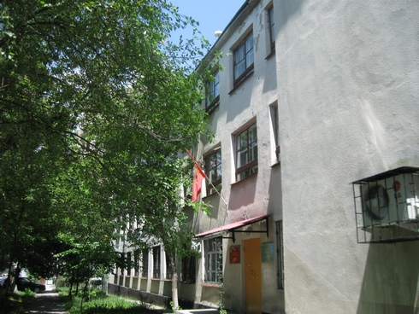
Здание Киргизгидромета · Владимира Петрова
ENGLISH Kyrgyzhydromet building
﻿ Kyrgyzhydromet building. Photo by V. Petrov The official date of formation of the hydrometeorological service of Kyrgyzstan is considered to be August 26, 1926, when the meteorological bureau was created under the People's Commissariat of Land of the Kyrgyz Autonomous Soviet Socialist Republic. However, systematic meteorological and hydrological observations began in the 80s of the 19th century. The first meteorological station on the territory
Source: https://bimap.su/description/frunze/33_Meteoslujba.txt · BIMAP
Фотографии и материалы принадлежат их авторам; лицензия не указана

BISHKEK
No information has been found for this period yet
42.86548, 74.58922

Фотография пока не добавлена
ENGLISH
No information has been found for this period yet.

