PISHPEK
No information has been found for this period yet
42.86551, 74.59093

Фотография пока не добавлена
ENGLISH
No information has been found for this period yet.

FRUNZE
Gortorg Warehouses
42.86551, 74.59093
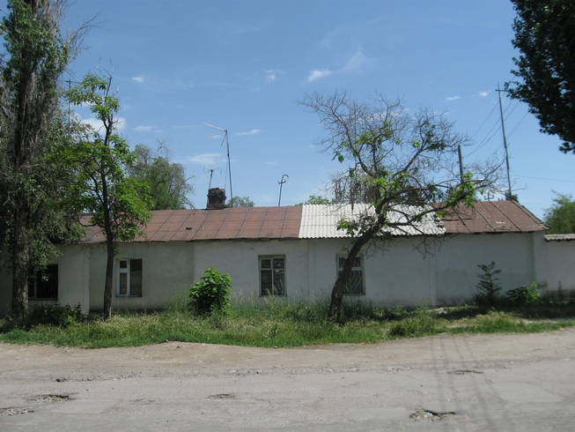
Склады горторга · Владимира Петрова
ENGLISH Gortorg Warehouses
﻿ Gortorg Warehouses. Photo by V. Petrov Warehouses of the City Trade Store.
Source: https://bimap.su/description/frunze/32_Sklady.txt · BIMAP
Фотографии и материалы принадлежат их авторам; лицензия не указана

BISHKEK
No information has been found for this period yet
42.86551, 74.59093

Фотография пока не добавлена
ENGLISH
No information has been found for this period yet.

