PISHPEK
No information has been found for this period yet
42.86773, 74.57409

Фотография пока не добавлена
ENGLISH
No information has been found for this period yet.

FRUNZE
Swimming pool on Molodaya Gvardiya Boulevard
42.86773, 74.57409
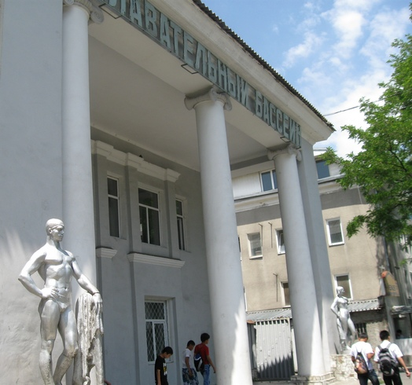
Бассейн на бульваре Молодая Гвардии · Владимира Петрова
ENGLISH Swimming pool on Molodaya Gvardiya Boulevard
﻿ Swimming pool on Molodaya Gvardiya. Photo by V. Petrov In 1983, Frunze had 8 swimming pools, 4 of which were indoor. The indoor swimming pool on Molodaya Gvardiya was built in 1958.
Source: https://bimap.su/description/frunze/30_Bassein.txt · BIMAP
Фотографии и материалы принадлежат их авторам; лицензия не указана

BISHKEK
No information has been found for this period yet
42.86773, 74.57409

Фотография пока не добавлена
ENGLISH
No information has been found for this period yet.

