PISHPEK
No information has been found for this period yet
42.86227, 74.54324

Фотография пока не добавлена
ENGLISH
No information has been found for this period yet.

FRUNZE
Railway Hospital
42.86227, 74.54324
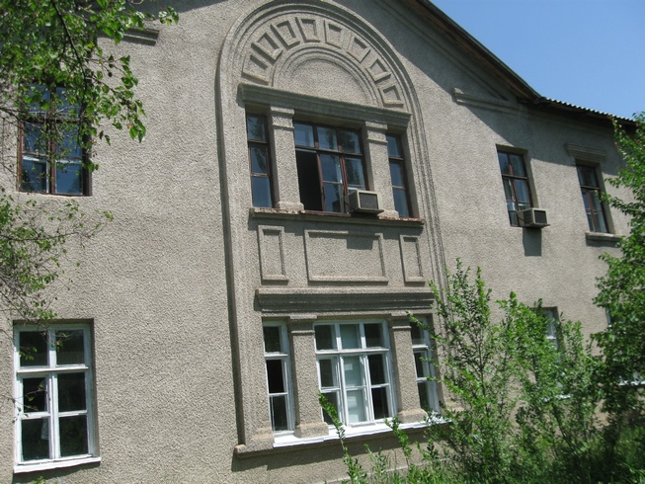
Железнодорожная больница · Владимира Петрова
ENGLISH Railway Hospital
﻿ Railway Hospital. Photo by Petrov Railway Hospital.
Source: https://bimap.su/description/frunze/28_Bolnitsa.txt · BIMAP
Фотографии и материалы принадлежат их авторам; лицензия не указана

BISHKEK
No information has been found for this period yet
42.86227, 74.54324

Фотография пока не добавлена
ENGLISH
No information has been found for this period yet.

