PISHPEK
No information has been found for this period yet
42.88781, 74.59645

Фотография пока не добавлена
ENGLISH
No information has been found for this period yet.

FRUNZE
House on Togolok Moldo street
42.88781, 74.59645
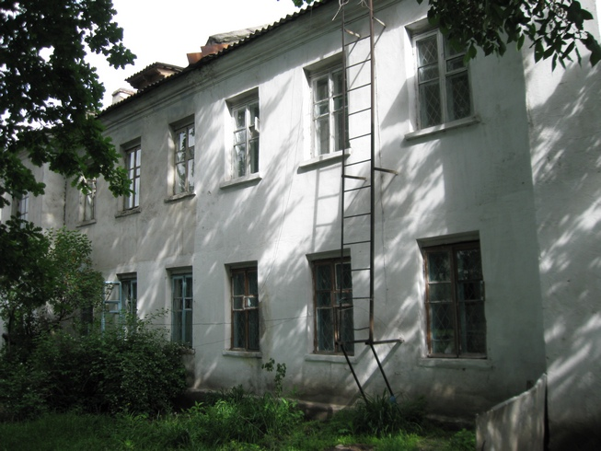
Дом на улице Тоголока Молдо · Владимира Петрова
ENGLISH House on Togolok Moldo street
﻿ House on Togolok Moldo. Photo by V. Petrov A two-story residential building built in the 40s on Togolok Moldo Street.
Source: https://bimap.su/description/frunze/25_Dom_na_Togolok_Moldo.txt · BIMAP
Фотографии и материалы принадлежат их авторам; лицензия не указана

BISHKEK
No information has been found for this period yet
42.88781, 74.59645

Фотография пока не добавлена
ENGLISH
No information has been found for this period yet.

