PISHPEK
No information has been found for this period yet
42.86691, 74.60315

Фотография пока не добавлена
ENGLISH
No information has been found for this period yet.

FRUNZE
House of Gapar Aitiev on Bokonbaev Street
42.86691, 74.60315
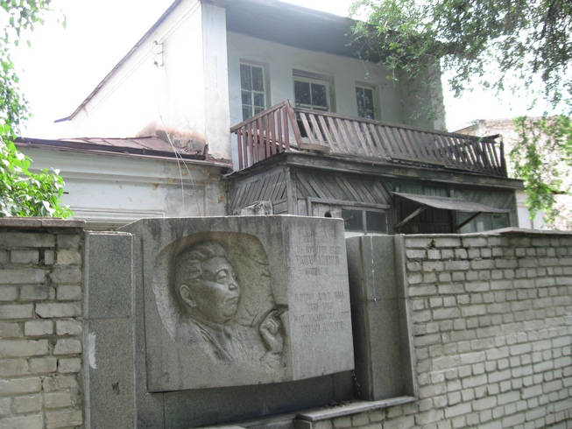
Дом Гапара Айтиева на улице Боконбаева · Владимира Петрова
ENGLISH House of Gapar Aitiev on Bokonbaev Street
﻿ House of Gapar Aitiev on Bokonbaeva Street. Photo by V. Petrov One of the first Soviet Kyrgyz artists, People's Artist of the Kyrgyz SSR and USSR, Hero of Socialist Labor Gapar Aitiev lived in this house.
Source: https://bimap.su/description/frunze/24_Dom_Aitieva.txt · BIMAP
Фотографии и материалы принадлежат их авторам; лицензия не указана

BISHKEK
No information has been found for this period yet
42.86691, 74.60315

Фотография пока не добавлена
ENGLISH
No information has been found for this period yet.

