PISHPEK
No information has been found for this period yet
42.86702, 74.60828

Фотография пока не добавлена
ENGLISH
No information has been found for this period yet.

FRUNZE
House on Bokonbaeva Street
42.86702, 74.60828
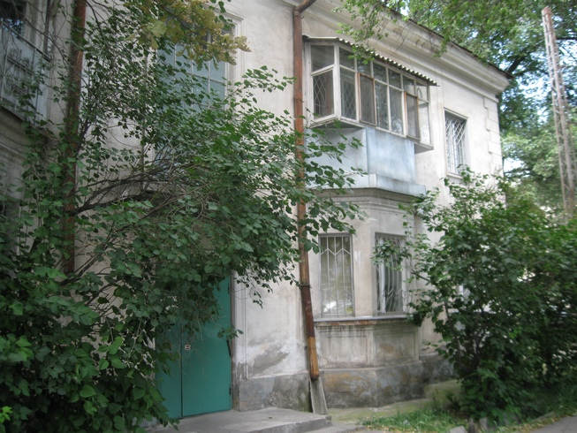
Дом на улице Боконбаева · Владимира Петрова
ENGLISH House on Bokonbaeva Street
﻿ House on Bokonbaev Street. Photo by V. Petrov Two-story residential building on Bokonbaev Street. The street is named after the Kyrgyz Soviet poet and playwright Djoomart Bokonbaev.
Source: https://bimap.su/description/frunze/23_Dom_na_Bokonbaeva.txt · BIMAP
Фотографии и материалы принадлежат их авторам; лицензия не указана

BISHKEK
No information has been found for this period yet
42.86702, 74.60828

Фотография пока не добавлена
ENGLISH
No information has been found for this period yet.

