PISHPEK
No information has been found for this period yet
42.86654, 74.61034

Фотография пока не добавлена
ENGLISH
No information has been found for this period yet.

FRUNZE
House on Bokonbaeva Street
42.86654, 74.61034
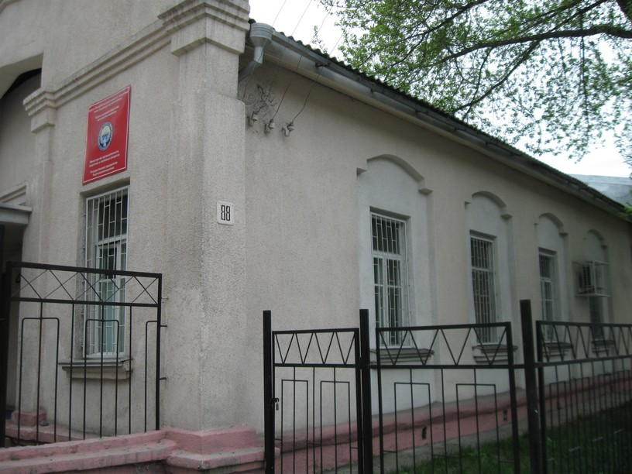
Дом на улице Боконбаева · Владимира Петрова
ENGLISH House on Bokonbaeva Street
﻿ House on Bokonbaev Street. Photo by V. Petrov A one-story residential building built in the 50s on Bokonbaev Street. The street is named after the Kyrgyz Soviet poet and playwright Djoomart Bokonbaev.
Source: https://bimap.su/description/frunze/22_Dom_na_Bokonbaeva.txt · BIMAP
Фотографии и материалы принадлежат их авторам; лицензия не указана

BISHKEK
No information has been found for this period yet
42.86654, 74.61034

Фотография пока не добавлена
ENGLISH
No information has been found for this period yet.

