PISHPEK
No information has been found for this period yet
42.86904, 74.60368

Фотография пока не добавлена
ENGLISH
No information has been found for this period yet.

FRUNZE
Suerkulov's House
42.86904, 74.60368
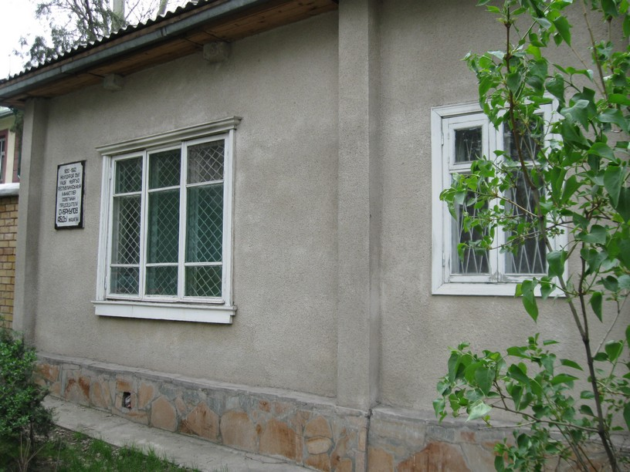
Дом Суеркулова · Владимира Петрова
ENGLISH Suerkulov's House
﻿ Suerkulov's House. Photo by V. Petrov The Chairman of the Council of Ministers of the Kirghiz SSR A. Suerkulov lived in this house.
Source: https://bimap.su/description/frunze/20_Dom_Suerkulova.txt · BIMAP
Фотографии и материалы принадлежат их авторам; лицензия не указана

BISHKEK
No information has been found for this period yet
42.86904, 74.60368

Фотография пока не добавлена
ENGLISH
No information has been found for this period yet.

