PISHPEK
No information has been found for this period yet
42.86890, 74.60424

Фотография пока не добавлена
ENGLISH
No information has been found for this period yet.

FRUNZE
Sydykbekov's House
42.86890, 74.60424
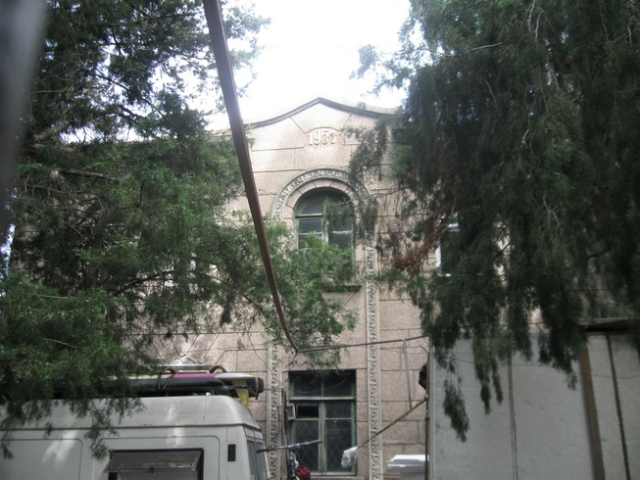
Дом Сыдыкбекова · Владимира Петрова
ENGLISH Sydykbekov's House
﻿ Sydykbekov's House. Photo by V. Petrov Residential house of the people's writer of the Kirghiz SSR Tugelbai Sydykbekov, built in 1953.
Source: https://bimap.su/description/frunze/19_Dom_Sydykbekova.txt · BIMAP
Фотографии и материалы принадлежат их авторам; лицензия не указана

BISHKEK
No information has been found for this period yet
42.86890, 74.60424

Фотография пока не добавлена
ENGLISH
No information has been found for this period yet.

