PISHPEK
No information has been found for this period yet
42.86998, 74.60426

Фотография пока не добавлена
ENGLISH
No information has been found for this period yet.

FRUNZE
House on Pervomaiskaya
42.86998, 74.60426
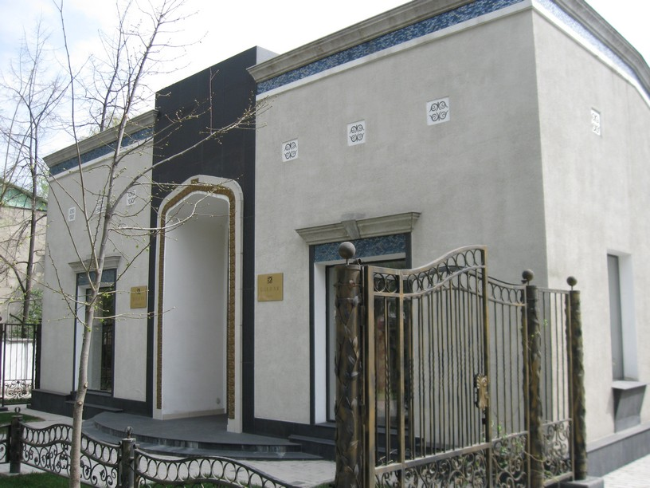
Дом на Первомайской · Владимира Петрова
ENGLISH House on Pervomaiskaya
﻿ House on Pervomaiskaya. Photo by V. Petrov Residential building on Pervomaiskaya built in the 50s.
Source: https://bimap.su/description/frunze/18_Dom_na_Pervomayskoy.txt · BIMAP
Фотографии и материалы принадлежат их авторам; лицензия не указана

BISHKEK
No information has been found for this period yet
42.86998, 74.60426

Фотография пока не добавлена
ENGLISH
No information has been found for this period yet.

