PISHPEK
No information has been found for this period yet
42.87047, 74.60436

Фотография пока не добавлена
ENGLISH
No information has been found for this period yet.

FRUNZE
House of the Chairmen of the Council of Ministers
42.87047, 74.60436
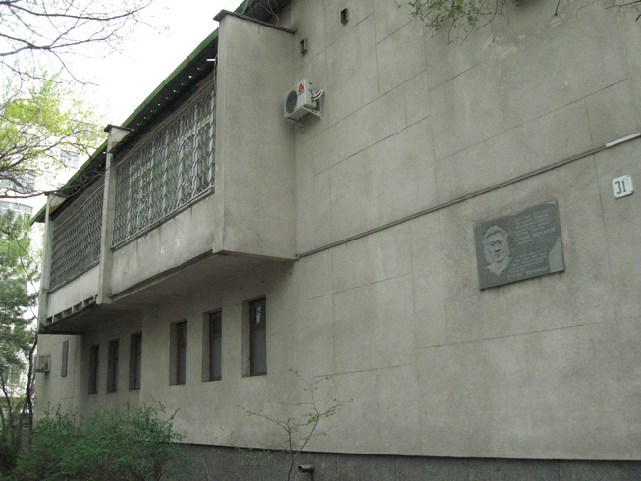
Дом председателей Совмина · Владимира Петрова
ENGLISH House of the Chairmen of the Council of Ministers
﻿ House of the Chairmen of the Council of Ministers. Photo by V. Petrov The chairmen of the Council of Ministers of the Kirghiz SSR A. Suyunbaev and S. Ibraimov lived in this house built in the 60s.
Source: https://bimap.su/description/frunze/17_Dom_Sovmina.txt · BIMAP
Фотографии и материалы принадлежат их авторам; лицензия не указана

BISHKEK
No information has been found for this period yet
42.87047, 74.60436

Фотография пока не добавлена
ENGLISH
No information has been found for this period yet.

