PISHPEK
No information has been found for this period yet
42.87086, 74.60379

Фотография пока не добавлена
ENGLISH
No information has been found for this period yet.

FRUNZE
The intersection of Pervomaiskaya and Kalinina streets
42.87086, 74.60379
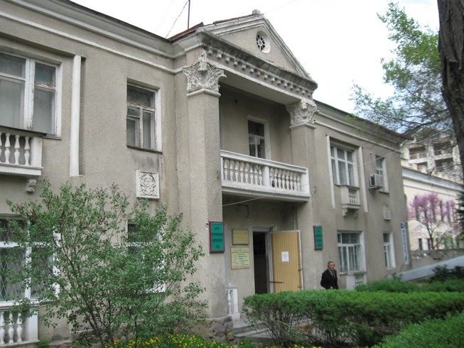
Пересечение улиц Первомайской и Калинина · Владимира Петрова
ENGLISH The intersection of Pervomaiskaya and Kalinina streets
﻿ Pervomaiskaya x Kalinina. Photo by V. Petrov The administrative building was built in the 50s.
Source: https://bimap.su/description/frunze/16_Dom_na_Pervomayskoy.txt · BIMAP
Фотографии и материалы принадлежат их авторам; лицензия не указана

BISHKEK
No information has been found for this period yet
42.87086, 74.60379

Фотография пока не добавлена
ENGLISH
No information has been found for this period yet.

