PISHPEK
No information has been found for this period yet
42.87011, 74.60025

Фотография пока не добавлена
ENGLISH
No information has been found for this period yet.

FRUNZE
Music School
42.87011, 74.60025
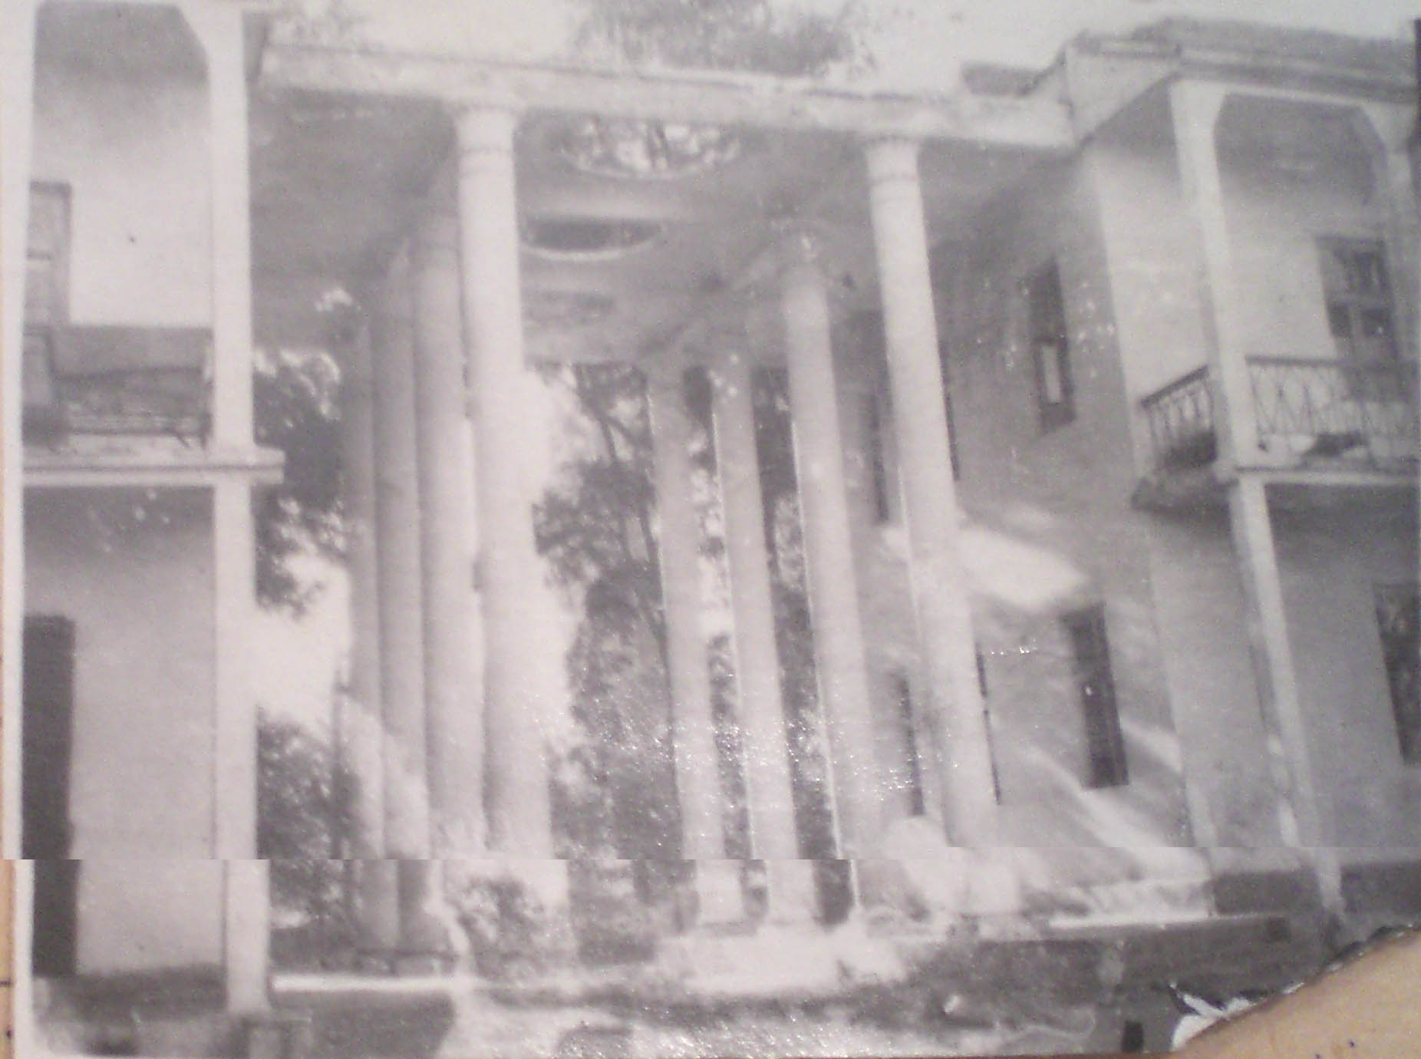
Музыкальное училище
ENGLISH Music School
﻿ Music School The Music and Choreography School was opened in 1939. In 1950 it was named after M. Kurenkeev. Trains music and dance teachers, artists, choir and orchestra conductors. In 1941, the Frunze newsreel studio, the first-born of Kirgizfilm, worked in this building. Musical and Choreographic School named after. M. Kurenkeeva trains artists and specialists in music, singing and dance. The first children's music school and philharmonic soc
Source: https://bimap.su/description/frunze/15_Muzychiliche.txt · BIMAP
Фотографии и материалы принадлежат их авторам; лицензия не указана

BISHKEK
No information has been found for this period yet
42.87011, 74.60025

Фотография пока не добавлена
ENGLISH
No information has been found for this period yet.

