PISHPEK
Church in the village of Lebedinovka
42.88795, 74.63881
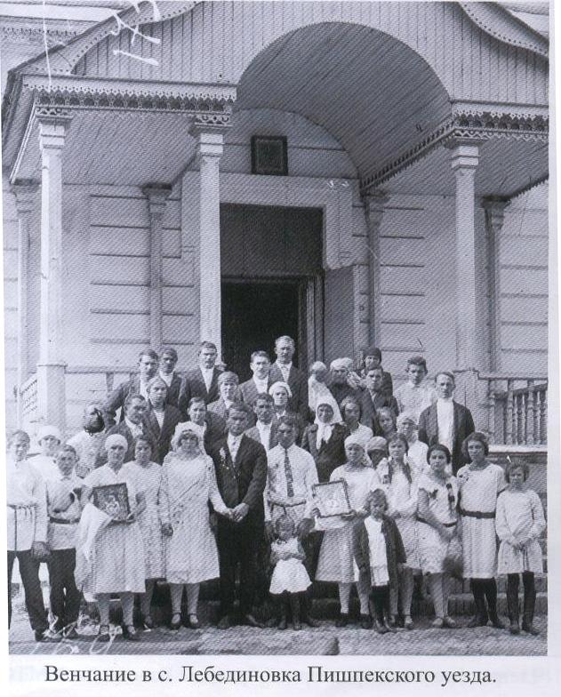
Церковь в селе Лебединовка
ENGLISH Church in the village of Lebedinovka
﻿ Church in the village of Lebedinovka. Built in 1864. Today the village of Lebedinovka is located within the city. It was founded by immigrants from Russia. The wooden tent church in the village of Lebedinovka was built by the first settlers and consecrated in the name of the Great Martyr Demetrius of Thessaloniki. It was located on the right bank of the Alamedin River.
Source: https://bimap.su/description/pishpek/22_Church.txt · BIMAP
Фотографии и материалы принадлежат их авторам; лицензия не указана

FRUNZE
No information has been found for this period yet
42.88795, 74.63881

Фотография пока не добавлена
ENGLISH
No information has been found for this period yet.

BISHKEK
No information has been found for this period yet
42.88795, 74.63881

Фотография пока не добавлена
ENGLISH
No information has been found for this period yet.

