PISHPEK
No information has been found for this period yet
42.88488, 74.61774

Фотография пока не добавлена
ENGLISH
No information has been found for this period yet.

FRUNZE
School
42.88488, 74.61774
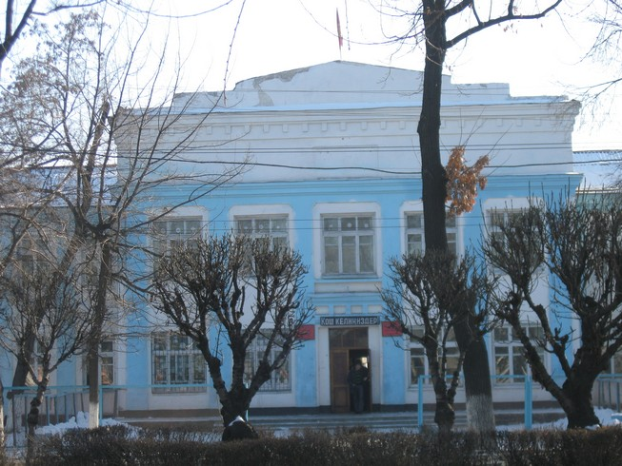
Школа · Владимира Петрова
ENGLISH School
﻿ School. Photo by Petrov One of the typical school buildings, built in 1940.
Source: https://bimap.su/description/frunze/14_Shkola.txt · BIMAP
Фотографии и материалы принадлежат их авторам; лицензия не указана

BISHKEK
No information has been found for this period yet
42.88488, 74.61774

Фотография пока не добавлена
ENGLISH
No information has been found for this period yet.

