PISHPEK
No information has been found for this period yet
42.88278, 74.60621

Фотография пока не добавлена
ENGLISH
No information has been found for this period yet.

FRUNZE
House on Baetova Street
42.88278, 74.60621
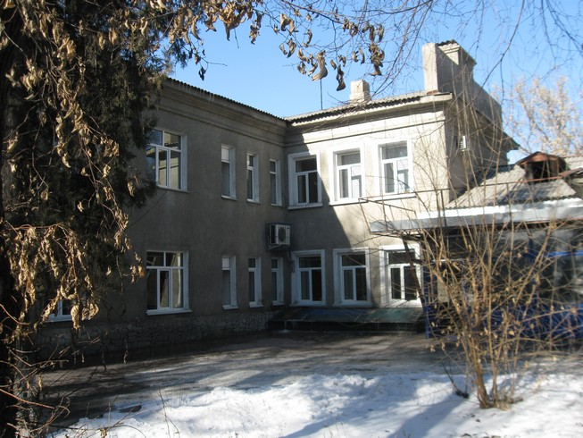
Дом на улице Баетова · Владимира Петрова
ENGLISH House on Baetova Street
﻿ House on Baetova, built in 1936. Photo by V. Petrov In this house on Baetov Street lived the people of the Kyrgyz SSR Vladimir Vlasov and Vladimir Fere - outstanding composers, founders of Kyrgyz musical and choreographic art, creators of Kyrgyz opera and ballet performances.
Source: https://bimap.su/description/frunze/13_Dom_na_Baetova.txt · BIMAP
Фотографии и материалы принадлежат их авторам; лицензия не указана

BISHKEK
No information has been found for this period yet
42.88278, 74.60621

Фотография пока не добавлена
ENGLISH
No information has been found for this period yet.

