PISHPEK
No information has been found for this period yet
42.87055, 74.55835

Фотография пока не добавлена
ENGLISH
No information has been found for this period yet.

FRUNZE
Monument to Lenin
42.87055, 74.55835
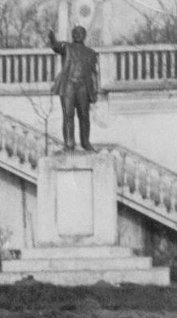
Памятник Ленину
ENGLISH Monument to Lenin
﻿ Monument to Lenin at the stadium of the Selmash plant The Selmashevets sports complex was built in 1958. It includes a stadium with stands for 5,000 spectators, sports grounds, gyms, and swimming pools.
Source: https://bimap.su/description/frunze/12a_Lenin.txt · BIMAP
Фотографии и материалы принадлежат их авторам; лицензия не указана

BISHKEK
No information has been found for this period yet
42.87055, 74.55835

Фотография пока не добавлена
ENGLISH
No information has been found for this period yet.

