PISHPEK
No information has been found for this period yet
42.87897, 74.55629

Фотография пока не добавлена
ENGLISH
No information has been found for this period yet.

FRUNZE
Monument to soldiers
42.87897, 74.55629
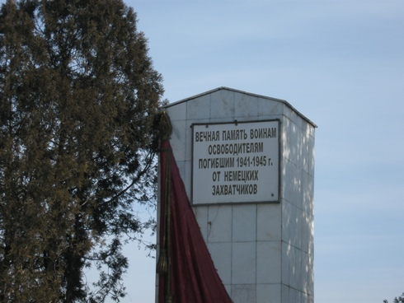
Памятник воинам
ENGLISH Monument to soldiers
﻿ Monument to soldiers In 1970, a monument was erected at the mass grave of soldiers who died of wounds during the Great Patriotic War in hospitals in the city of Frunze (architects K. Galiev, N. Dementyev).
Source: https://bimap.su/description/frunze/11_Pamiatnik_voinam.txt · BIMAP
Фотографии и материалы принадлежат их авторам; лицензия не указана

BISHKEK
No information has been found for this period yet
42.87897, 74.55629

Фотография пока не добавлена
ENGLISH
No information has been found for this period yet.

